UNITED STATES
SECURITIES AND EXCHANGE COMMISSION
Washington, D.C. 20549
_______________________

FORM 8-K

CURRENT REPORT

Pursuant to Section 13 or 15(d) of the Securities Exchange Act of 1934

Date of report (Date of earliest event reported): May 13, 2026

PRESTIGE CONSUMER HEALTHCARE INC.
(Exact Name of Registrant as Specified in Charter)

Delaware |  |  |  |  |  | 001-32433 |  |  |  |  |  | 20-1297589
(State or Other Jurisdiction of Incorporation) |  |  |  |  |  | (Commission File Number) |  |  |  |  |  | (IRS Employer Identification No.)

660 White Plains Road, Tarrytown, New York 10591
(Address of Principal Executive Offices) (Zip Code)

(914) 524-6800
(Registrant's telephone number, including area code)

(Former Name or Former Address, if Changed Since Last Report.)

Check the appropriate box below if the Form 8-K filing is intended to simultaneously satisfy the filing obligation of the registrant under any of the following provisions (see General Instruction A.2. below):

☐ Written communications pursuant to Rule 425 under the Securities Act (17 CFR 230.425)

☐ Soliciting material pursuant to Rule 14a-12 under the Exchange Act (17 CFR 240.14a-12)

☐ Pre-commencement communications pursuant to Rule 14d-2(b) under the Exchange Act (17 CFR 240.14d-2(b))

☐ Pre-commencement communications pursuant to Rule 13e-4(c) under the Exchange Act (17 CFR 240.13e-4(c))
Securities registered pursuant to Section 12(b) of the Act:
Title of each class |  |  | Trading Symbol(s) |  |  | Name of each exchange on which registered
Common stock, par value $0.01 per share |  |  | PBH |  |  | New York Stock Exchange
Indicate by check mark whether the registrant is an emerging growth company as defined in Rule 405 of the Securities Act of 1933 (§ 230.405 of this chapter) or Rule 12b-2 of the Securities Exchange Act of 1934 (§ 240.12b-2 of this chapter).
Emerging Growth Company |  |  | ☐
If an emerging growth company, indicate by check mark if the registrant has elected not to use the extended transition period for complying with any new or revised financial accounting standards provided pursuant to Section 13(a) of the Exchange Act.
☐

Item 1.01 Entry into a Material Definitive Agreement.

On May 10, 2026, PBH Australia Holding Company Pty Limited (“Purchaser”), an Australian company and a wholly owned indirect subsidiary of Prestige Consumer Healthcare Inc. (the “Company”), and Care Pharmaceuticals Pty Limited (“Care”), an Australian company and a wholly owned indirect subsidiary of the Company, entered into a definitive agreement (the “Sale and Purchase Deed”) with Tailor Investments Pty Limited and Standive Pty Limited, both Australian companies (the “Sellers”), Steven David Sher, Delon Badler and Clive Howard Sher. The Sale and Purchase Deed provides that, upon the terms and subject to the conditions set forth therein, Purchaser will acquire all of the shares of LaCorium Health Australia Pty Limited, Stantail Trading Pty Limited, Stantail International Pty Limited, Brands Worldwide Holdings I.P. Pty Limited, and Laderma Holdings Pty Limited, each an Australian company, collectively a leader in Australian therapeutic skin care designed to treat individual skin ailments, from the Sellers for approximately $150 million in cash, subject to certain adjustments, including indebtedness, as provided in the Sale and Purchase Deed (the “Transaction”).

The Company expects the Transaction to close in the second quarter of fiscal 2027, subject to the satisfaction or waiver of customary conditions to closing.

The Sale and Purchase Deed contains customary representations, warranties, indemnities, and covenants of both Purchaser and the Sellers, as well as indemnification provisions that are subject to specified limitations. Purchaser has obtained warranty and indemnity insurance, which serves as Purchaser’s sole recourse for losses related to breaches of the Sellers’ representations, warranties and indemnities, other than in the case of fraud. Subject to certain exceptions and limitations, Purchaser and Care, on the one hand, and the Sellers and Steven David Sher, on the other hand, have agreed to indemnify each other for breaches of post-closing covenants, fraud and other specified matters contained in the Sale and Purchase Deed.

The Sale and Purchase Deed also contains certain customary termination rights for each of Purchaser and the Sellers. The Sale and Purchase Deed may be terminated by either Purchaser or the Sellers prior to October 1, 2026 if the other party is in breach of the Sale and Purchase Deed, such that it has not met its closing conditions and has not or is not able to cure such breach.

The foregoing description of the terms of the Sale and Purchase Deed does not purport to be complete and is qualified in its entirety by reference to the full text of the Sale and Purchase Deed. The Company expects to file a copy of the Sale and Purchase Deed as an exhibit to its Quarterly Report on Form 10-Q for the quarter ended June 30, 2026.

The Sale and Purchase Deed contains various representations and warranties made by the parties solely for purposes of the Sale and Purchase Deed and as of specific dates set forth therein, which were the product of negotiations, and may be subject to important qualifications and limitations included in confidential disclosure letter of the Sale and Purchase Deed. Certain representations and warranties in the Sale and Purchase Deed were used for the purpose of allocating risk between the parties, rather than establishing matters of fact. Furthermore, the representations and warranties may be subject to standards of materiality applicable to the parties that may be different from those applicable to the Company’s stockholders. Additionally, information concerning the subject matter of such representations and warranties may change after the date of the Sale and Purchase Deed, which subsequent information may or may not be fully reflected in the Company’s public disclosures. Accordingly, such representations and warranties in the Sale and Purchase Deed may not constitute the actual state of facts about the Sellers, the Company, or Purchaser. Stockholders of the Company are not third-party beneficiaries under the Sale and Purchase Deed t and should not rely on the representations, warranties, and covenants or any descriptions thereof as characterizations of the actual state of facts or condition of the Sellers (or any of its subsidiaries), the Company, or Purchaser or any of their respective subsidiaries or affiliates.

Item 2.02 Results of Operations and Financial Condition.

On May 13, 2026, the Company announced financial results for the fiscal quarter and year ended March 31, 2026. A copy of the press release announcing the Company's earnings results for the fiscal quarter and year ended March 31, 2026 is attached to this Current Report on Form 8-K as Exhibit 99.1 and incorporated herein by reference.

Item 7.01. Regulation FD Disclosure.
On May 13, 2026, representatives of the Company began making presentations to investors regarding the Company's financial results for the quarter and year ended March 31, 2026, using slides containing the information attached to this Current Report on Form 8-K as Exhibit 99.2 (the “Investor Presentation”) and incorporated here-in by reference. The Company expects

to use the Investor Presentation, in whole or in part, and possibly with modifications, in connection with presentations to investors, analysts and others during the fiscal year ended March 31, 2027.

By filing this Current Report on Form 8-K and furnishing the information contained herein, the Company makes no admission as to the materiality of any information in this report that is required to be disclosed solely by reason of Regulation FD.

The information contained in the Investor Presentation is summary information that is intended to be considered in the context of the Company's Securities and Exchange Commission (“SEC”) filings and other public announcements that the Company may make, by press release or otherwise, from time to time. The Company undertakes no duty or obligation to publicly update or revise the information contained in this report, although it may do so from time to time as its management believes is warranted. Any such updating may be made through the filing of other reports or documents with the SEC, through press releases or through other public disclosure.

The information presented in Items 2.02 and 7.01 of this Current Report on Form 8-K and Exhibits 99.1 and 99.2 shall not be deemed to be “filed” for purposes of Section 18 of the Securities Exchange Act of 1934, as amended (the “Exchange Act”), or otherwise subject to the liabilities of that section, unless the Company specifically states that the information is to be considered “filed” under the Exchange Act or specifically incorporates it by reference into a filing under the Securities Act of 1933, as amended, or the Exchange Act.
Item 9.01 Financial Statements and Exhibits.

(d) Exhibits.

Exhibit |  |  |  |  |  | Description
99.1 |  |  |  |  |  | Press Release dated May 13, 2026 announcing the Company's financial results for the fiscal quarter and year ended March 31, 2026 (furnished only).
99.2 |  |  |  |  |  | Investor Relations Slideshow in use beginning May 13, 2026 (furnished only).
104 |  |  |  |  |  | Cover Page Interactive Data File (the cover page XBRL tags are embedded within the Inline XBRL document).

SIGNATURES

Pursuant to the requirements of the Securities Exchange Act of 1934, the registrant has duly caused this report to be signed on its behalf by the undersigned hereunto duly authorized.

Dated: |  |  | May 13, 2026 |  |  | PRESTIGE CONSUMER HEALTHCARE INC.
 |  |  |  |  |  | By: |  |  | /s/ Christine Sacco
 |  |  |  |  |  |  |  |  | Name: Christine Sacco
 |  |  |  |  |  |  |  |  | Title: Chief Financial Officer & Chief Operating Officer

Exhibit 99.1

Prestige Consumer Healthcare Inc. Reports Fiscal 2026 Results, Announces Acquisition of LaCorium Health

•Reported revenues of $281.6 million in Q4 and $1,088.7 million in fiscal year 2026
•Diluted EPS of $3.91 and Adjusted Diluted EPS of $4.38 in fiscal year 2026
•Announces agreement to acquire LaCorium Health, a leader in Australian therapeutic skin care
•Introducing Outlook for Fiscal 2027 Organic Revenue Growth and Adjusted Diluted EPS of 1% to 3%, respectively, excluding the impact of acquisitions

TARRYTOWN, N.Y.--(GLOBE NEWSWIRE)-May 13, 2026-- Prestige Consumer Healthcare Inc. (NYSE:PBH) today reported financial results for its fourth quarter and fiscal year ended March 31, 2026.

“Our fiscal 2026 demonstrated the resilience of our business model in a challenging consumer backdrop.
Our diversified portfolio of leading brands with deep consumer heritage supports a durable financial profile and drives strong, growing free cash flow. In fiscal 2026, this resulted in $246.4 million of free cash flow driven by continued strength that included strong growth for Fleet®, Dramamine®, and Hydralyte® in our Gastrointestinal category, which helped partially offset the impacts of limited eye care production as well as fourth quarter shipping disruptions in the Middle East.”

Fourth Fiscal Quarter Ended March 31, 2026

Reported revenues in the fourth quarter of fiscal 2026 of $281.6 million decreased 5.0% from $296.5 million in the fourth quarter of fiscal 2025 and decreased 6.4% versus the prior fiscal fourth quarter excluding the impact of foreign currency. The revenue performance versus the prior year comparable period reflected lower Eye & Ear Care category sales, driven primarily by limited ability to supply demand for Clear Eyes® and the expected headwind associated with accelerated order timing in the fourth quarter of the prior year.

Reported net income for the fourth quarter of fiscal 2026 was $53.9 million versus the prior fiscal fourth quarter of $50.1 million. Diluted earnings per share of $1.13 for the fourth quarter of fiscal 2026 compared to $1.00 in the prior year comparable period. Non-GAAP adjusted net income for the fourth quarter of fiscal 2026 was $58.5 million compared to $65.9 million in the prior year comparable period. Non-GAAP adjusted diluted earnings per share of $1.23 for the fourth quarter of fiscal 2026 compared to $1.32 in the prior year comparable period.

Adjustments to net income in the fourth quarter of fiscal 2026 included certain costs associated with Pillar5, our recently acquired sterile eye care facility, including various costs associated with improving and optimizing the facility for increases in long-term capacity, as well as costs associated with acquisitions and associated tax adjustments as well as an adjustment to normalize the tax rate to account for discrete items.

Adjustments to net income in the fourth quarter of fiscal 2025 included non-cash tradename impairments and an associated tax adjustment as well as an adjustment to normalize the tax rate to account for discrete items.

Fiscal Year Ended March 31, 2026

Reported revenues for fiscal year 2026 totaled $1,088.7 million, a decrease of 4.3% versus revenues of $1,137.8 million in the prior fiscal year. Revenues decreased 4.5% versus the prior fiscal year excluding the impact of foreign currency. The revenue performance for the fiscal year reflected the limited ability to supply demand for Clear Eyes®.

Reported net income for fiscal 2026 of $190.3 million compared to $214.6 million in the prior year. Reported fiscal 2026 diluted earnings per share was $3.91, compared to $4.29 in the prior year. On a non-GAAP adjusted basis, fiscal 2026 adjusted net income of $213.3 million and adjusted diluted earnings per share of $4.38 compared to adjusted net income and adjusted diluted earnings per share of $226.3 million and $4.52 in the prior year, respectively.

Adjustments to net income in fiscal 2026 include certain costs associated with Pillar5, our recently acquired sterile eye care facility, including various costs associated with improving and optimizing the facility for long-term capacity. Additional adjustments to net income in fiscal 2026 include a supplier loan write-off, costs associated with acquisitions, and associated tax adjustments as well as an adjustment to normalize the tax rate to account for discrete items.

Adjustments to net income in fiscal 2025 included non-cash tradename impairments associated with non-strategic indefinite-lived and finite-lived intangible assets, and an associated tax adjustment as well as an adjustment to normalize the tax rate to account for discrete items.

Segment Review

North American OTC Healthcare: Segment revenues of $234.5 million for the fourth quarter of fiscal 2026 decreased compared to the prior year comparable quarter's segment revenues of $248.9 million. The revenue decrease was primarily attributable to lower Eye & Ear Care category sales, driven by limited ability to supply demand for Clear Eyes®.

For fiscal 2026, reported revenues for the North American OTC segment were $913.6 million, which compared to $960.0 million in the prior year. The revenue decrease was primarily attributable to lower Eye & Ear Care category sales, driven by limited ability to supply demand for Clear Eyes® and the expected headwind associated with accelerated order timing in Q4 of the prior year.

International OTC Healthcare: Fiscal fourth quarter 2026 segment revenues of $47.1 million compared to $47.6 million reported in the prior year comparable period. The lower revenue performance was driven by shipping disruptions in the Middle East and lower Eye & Ear Care category sales.

For fiscal 2026, reported revenues for the International OTC Healthcare segment were $175.1 million, a decrease over the prior year’s revenues of $177.8 million, driven by lower Eye & Ear Care category sales and fourth quarter shipping disruptions, which were partly offset by an increase in the Women’s Health and Cough & Cold categories.

Free Cash Flow and Balance Sheet

The Company's net cash provided by operating activities for fiscal 2026 was $257.6 million, an increase compared to $251.5 million in the prior year. Non-GAAP free cash flow in fiscal 2026 of $246.4 million increased from $243.3 million in the prior year.

In fiscal 2026, the Company opportunistically repurchased 2.3 million shares at a total investment of approximately $156 million.

The Company's net debt position as of March 31, 2026 was approximately $0.9 billion, resulting in a covenant-defined leverage ratio of 2.6x.

LaCorium Acquisition

The Company today is also announcing a definitive agreement to acquire LaCorium Health (“LaCorium”), for approximately $150 million in cash. The transaction, subject to customary conditions, is expected to close in second quarter fiscal 2027.

LaCorium generated approximately $40 million in trailing twelve months revenue through February 28, 2026 and is expected to generate approximately $12 million in EBITDA including the benefits from anticipated synergies once the business is fully integrated. LaCorium is delivering strong growth, and the Company expects double-digit net sales growth in calendar 2026 driven by a combination of category growth, innovation, and continued geographic expansion.

Founded in Australia and introduced in 1998, LaCorium is a leader in Australian therapeutic skin care designed to treat individual skin ailments. Products are sold under the Dermal Therapy®, Flexitol®, and Crampeze® brands in need-state categories such as lip care (cold sores), skin care (eczema & acne), foot care (heel balm, antifungal), hair & scalp (eczema), and more. Approximately 75% of sales are in Australia, where the brand maintains a leading #1 market position in lip care and #3 in foot care. Globally, products are sold in approximately 20 countries across North America, Asia, and the Middle East under the Flexitol® and Crampeze® brand names.

Fiscal 2027 Outlook

Ron Lombardi, Chief Executive Officer, stated, “As we begin fiscal 2027, we anticipate our proven financial model and diversified portfolio of leading, trusted brands will result in sales growth approximate to our long-term expectations. Our organic sales growth outlook range reflects strong momentum for our diversified portfolio of leading strategic brands and also accounts for variability in eye care supply as we prioritize quality and increase output of Clear Eyes® as well as an expectation for a continued volatile consumer backdrop.”

He continued, “We anticipate adjusted diluted EPS of $4.42 to $4.51, following sales growth and adjusted free cash flow of $250 million or more. We expect to provide an updated outlook for the year after the completion of the acquisitions of Breathe Right® and LaCorium, which we anticipate closing in June and July, respectively. Regarding recent fluctuations in energy costs, just like other inflationary periods of the past, we plan to leverage our leading portfolio, diverse supply chain, and agile operating model to manage and mitigate these costs as they arise in our fiscal 2027 and moving forward,” said Ron Lombardi, Chief Executive Officer of Prestige Consumer Healthcare.

 |  |  | Fiscal 2027 Outlook
Revenue |  |  | $1,100 million to $1,121 million
Organic Revenue Growth |  |  | +1.0% to +3.0%
Adjusted Diluted E.P.S. |  |  | $4.42 to $4.51
Free Cash Flow |  |  | $250 million or more

Medium-Term Outlook

“Based on the acquisitions expected to close early in fiscal 2027, our expanded portfolio of leading brands, and the continued recovery of our eye care capacity, we expect a meaningful strengthening of our overall business profile and positioning. Combined with our continued disciplined approach to capital allocation, this positions us to deliver growth over the next three years that exceeds our long-term targets. Over this period, we expect to generate an approximately 10% annual CAGR for revenue growth, an EPS growth CAGR of approximately 8%, and exceptional free cash flow approaching $900 million in aggregate. This level of cash generation is expected to enable a rapid return to historical leverage levels, further enhancing shareholder value. We have a long track record of delivering superior shareholder value and remain focused on executing our business model to achieve these objectives and drive continued value creation” Mr. Lombardi concluded.

Fiscal 2026 Conference Call, Accompanying Slide Presentation and Replay

The Company will host a conference call to review its fourth quarter and fiscal 2026 results tomorrow morning, May 14, 2026 at 8:30 a.m. ET. The Company provides a live Internet webcast, a slide presentation to accompany the call, as well as an archived replay, all of which can be accessed from the Investor Relations page of the Company's website at http://www.prestigeconsumerhealthcare.com/. To participate in the conference call via phone, participants may register for the call here to receive dial-in details and a unique pin. While not required, it is recommended to join 10 minutes prior to the event start. The slide presentation can be accessed from the Investor Relations page of the Company’s website by clicking on Webcasts and Presentations.

A conference call replay will be available for approximately one week following completion of the live call and can be accessed on the Company’s Investor Relations page.

Non-GAAP and Other Financial Information

In addition to financial results reported in accordance with generally accepted accounting principles (GAAP), we have provided certain non-GAAP financial information in this release to aid investors in understanding the Company's performance. Each non-GAAP financial measure is defined and reconciled to its most closely related GAAP financial measure in the “About Non-GAAP Financial Measures” section at the end of this earnings release.

Note Regarding Forward-Looking Statements

This news release contains "forward-looking statements" within the meaning of the federal securities laws that are intended to qualify for the safe harbor from liability established by the Private Securities Litigation Reform Act of 1995. "Forward-looking statements" generally can be identified by the use of forward-looking terminology such as “durable,” “growing,” "outlook," “forecast,” "may," "will," "would," "expect," “positioned,” “anticipate,” “plan,” or "continue" (or the negative or other derivatives of each of these terms) or similar terminology. The "forward-looking statements" include, without limitation, statements regarding the Company's future operating results including revenues, organic growth, adjusted diluted earnings per share, and free cash flow; the strength of the Company’s financial profile, improvements in eye care supply from the acquisition of Pillar5 and increased manufacturing capacity from capital investments; LaCorium’s net sales growth; the timing of the closing of acquisitions; the impact of volatile markets on consumer spending; the timing of the Company’s return to historical leverage; and the Company’s ability to manage and mitigate energy costs and enhance shareholder value. These statements are based on management's estimates and assumptions with respect to future events and financial performance and are believed to be reasonable, though are inherently uncertain and difficult to predict. Actual results could differ materially from those expected as a result of a variety of factors, including the impact of business and economic conditions, including as a result of evolving U.S. and international tariffs and trade actions, labor shortages, inflation and geopolitical instability, consumer trends, the impact of the Company’s advertising and marketing and new product development initiatives, customer inventory management initiatives, fluctuating foreign exchange rates, competitive pressures, and the ability of the Company’s manufacturing operations and third party manufacturers and logistics providers and suppliers to meet demand for its products and to avoid inflationary cost increases and disruption. A discussion of other factors that could cause results to vary is included in the Company's Annual Report on Form 10-K for the year ended March 31, 2025 and other periodic reports filed with the Securities and Exchange Commission.

About Prestige Consumer Healthcare Inc.

Prestige Consumer Healthcare is a leading consumer healthcare products company with sales throughout the U.S. and Canada, Australia, and in certain other international markets. The Company’s diverse portfolio of brands include Monistat® and Summer’s Eve® women's health products, BC® and Goody's® pain relievers, Clear Eyes® and TheraTears® eye care products, DenTek® specialty oral care products, Dramamine® motion sickness treatments, Fleet® enemas and glycerin suppositories, Chloraseptic® and Luden's® sore throat treatments and drops, Compound W® wart treatments, Little Remedies® pediatric over-the-counter products, Boudreaux’s Butt Paste® diaper rash ointments, Nix® lice treatment, Debrox® earwax remover, Gaviscon® antacid in Canada, and Hydralyte® rehydration products and the Fess® line of nasal and sinus care products in Australia. Visit the Company's website at
www.prestigeconsumerhealthcare.com.

Prestige Consumer Healthcare Inc.
Consolidated Statement of Income and Comprehensive Income
(Unaudited)

 |  |  |  |  |  | Three Months Ended March 31, |  |  |  |  |  |  |  |  |  |  |  | Year  Ended March 31,
(In thousands, except per share data) |  |  |  |  |  | 2026 |  |  |  |  |  | 2025 |  |  |  |  |  | 2026 |  |  |  |  |  | 2025
Total Revenues |  |  |  |  |  | 281,617 |  |  |  |  |  | 296,518 |  |  |  |  |  | 1,088,705 |  |  |  |  |  | 1,137,762
Cost of Sales
Cost of sales excluding depreciation |  |  |  |  |  | 132,404 |  |  |  |  |  | 124,318 |  |  |  |  |  | 482,794 |  |  |  |  |  | 494,416
Cost of sales depreciation |  |  |  |  |  | 2,914 |  |  |  |  |  | 2,190 |  |  |  |  |  | 10,333 |  |  |  |  |  | 8,883
Cost of sales |  |  |  |  |  | 135,318 |  |  |  |  |  | 126,508 |  |  |  |  |  | 493,127 |  |  |  |  |  | 503,299
Gross profit |  |  |  |  |  | 146,299 |  |  |  |  |  | 170,010 |  |  |  |  |  | 595,578 |  |  |  |  |  | 634,463
Operating Expenses
Advertising and marketing |  |  |  |  |  | 35,089 |  |  |  |  |  | 37,004 |  |  |  |  |  | 148,782 |  |  |  |  |  | 155,723
General and administrative |  |  |  |  |  | 30,280 |  |  |  |  |  | 27,050 |  |  |  |  |  | 116,447 |  |  |  |  |  | 108,209
Depreciation and amortization |  |  |  |  |  | 5,438 |  |  |  |  |  | 5,062 |  |  |  |  |  | 20,940 |  |  |  |  |  | 21,290
Goodwill and tradename impairment |  |  |  |  |  | — |  |  |  |  |  | 12,466 |  |  |  |  |  | — |  |  |  |  |  | 12,466
Total operating expenses |  |  |  |  |  | 70,807 |  |  |  |  |  | 81,582 |  |  |  |  |  | 286,169 |  |  |  |  |  | 297,688
Operating income |  |  |  |  |  | 75,492 |  |  |  |  |  | 88,428 |  |  |  |  |  | 309,409 |  |  |  |  |  | 336,775
Other expense (income)
Interest expense, net |  |  |  |  |  | 11,428 |  |  |  |  |  | 10,759 |  |  |  |  |  | 42,339 |  |  |  |  |  | 47,632
Other expense (income), net |  |  |  |  |  | (708) |  |  |  |  |  | 3,710 |  |  |  |  |  | 9,574 |  |  |  |  |  | 4,954
Total other expense, net |  |  |  |  |  | 10,720 |  |  |  |  |  | 14,469 |  |  |  |  |  | 51,913 |  |  |  |  |  | 52,586
Income before income taxes |  |  |  |  |  | 64,772 |  |  |  |  |  | 73,959 |  |  |  |  |  | 257,496 |  |  |  |  |  | 284,189
Provision for income taxes |  |  |  |  |  | 10,844 |  |  |  |  |  | 23,831 |  |  |  |  |  | 67,195 |  |  |  |  |  | 69,584
Net income |  |  |  |  |  | $ | 53,928 |  |  |  |  | $ | 50,128 |  |  |  |  | $ | 190,301 |  |  |  |  | $ | 214,605
Earnings per share:
Basic |  |  |  |  |  | $ | 1.14 |  |  |  |  | $ | 1.01 |  |  |  |  | $ | 3.93 |  |  |  |  | $ | 4.32
Diluted |  |  |  |  |  | $ | 1.13 |  |  |  |  | $ | 1.00 |  |  |  |  | $ | 3.91 |  |  |  |  | $ | 4.29
Weighted average shares outstanding:
Basic |  |  |  |  |  | 47,433 |  |  |  |  |  | 49,656 |  |  |  |  |  | 48,456 |  |  |  |  |  | 49,697
Diluted |  |  |  |  |  | 47,686 |  |  |  |  |  | 50,064 |  |  |  |  |  | 48,720 |  |  |  |  |  | 50,080
Comprehensive income, net of tax:
Currency translation adjustments |  |  |  |  |  | 1,962 |  |  |  |  |  | 2,586 |  |  |  |  |  | 9,387 |  |  |  |  |  | (3,083)
Unrecognized net loss on pension plans |  |  |  |  |  | (96) |  |  |  |  |  | (81) |  |  |  |  |  | (96) |  |  |  |  |  | (81)
Total other comprehensive income (loss) |  |  |  |  |  | 1,866 |  |  |  |  |  | 2,505 |  |  |  |  |  | 9,291 |  |  |  |  |  | (3,164)
Comprehensive income |  |  |  |  |  | $ | 55,794 |  |  |  |  | $ | 52,633 |  |  |  |  | $ | 199,592 |  |  |  |  | $ | 211,441

Prestige Consumer Healthcare Inc.
Consolidated Balance Sheet
(Unaudited)

(In thousands) |  |  | March 31,
 |  |  | 2026 |  |  |  |  |  | 2025
Assets
Current assets
Cash and cash equivalents |  |  | $ | 63,868 |  |  |  |  | $ | 97,884
Accounts receivable, net of allowance of $18,187 and $16,314, respectively |  |  | 191,920 |  |  |  |  |  | 194,293
Inventories |  |  | 159,132 |  |  |  |  |  | 147,709
Prepaid expenses and other current assets |  |  | 16,564 |  |  |  |  |  | 8,442
Total current assets |  |  | 431,484 |  |  |  |  |  | 448,328
Property, plant and equipment, net |  |  | 121,689 |  |  |  |  |  | 74,548
Operating lease right-of-use assets |  |  | 27,780 |  |  |  |  |  | 28,238
Finance lease right-of-use assets, net |  |  | 21,776 |  |  |  |  |  | 25,056
Goodwill |  |  | 581,109 |  |  |  |  |  | 527,425
Intangible assets, net |  |  | 2,299,605 |  |  |  |  |  | 2,295,350
Other long-term assets |  |  | 10,870 |  |  |  |  |  | 3,273
Total Assets |  |  | $ | 3,494,313 |  |  |  |  | $ | 3,402,218
Liabilities and Stockholders' Equity
Current liabilities
Accounts payable |  |  | $ | 22,791 |  |  |  |  | $ | 18,925
Accrued interest payable |  |  | 15,578 |  |  |  |  |  | 15,703
Operating lease liabilities, current portion |  |  | 6,910 |  |  |  |  |  | 6,047
Finance lease liabilities, current portion |  |  | 2,656 |  |  |  |  |  | 2,490
Other accrued liabilities |  |  | 72,989 |  |  |  |  |  | 63,458
Total current liabilities |  |  | 120,924 |  |  |  |  |  | 106,623
Long-term debt, net |  |  | 993,953 |  |  |  |  |  | 992,357
Deferred income tax liabilities |  |  | 447,417 |  |  |  |  |  | 419,594
Long-term operating lease liabilities, net of current portion |  |  | 20,955 |  |  |  |  |  | 22,732
Long-term finance lease liabilities, net of current portion |  |  | 17,968 |  |  |  |  |  | 20,624
Other long-term liabilities |  |  | 5,580 |  |  |  |  |  | 5,391
Total Liabilities |  |  | 1,606,797 |  |  |  |  |  | 1,567,321
Stockholders' Equity
Preferred stock - $0.01 par value
Authorized - 5,000 shares
Issued and outstanding - None |  |  | — |  |  |  |  |  | —
Common stock - $0.01 par value
Authorized - 250,000 shares
Issued – 56,211 shares at March 31, 2026 and 56,010 shares at March 31, 2025 |  |  | 562 |  |  |  |  |  | 560
Additional paid-in capital |  |  | 608,520 |  |  |  |  |  | 593,402
Treasury stock, at cost – 8,892 shares at March 31, 2026 and 6,501 at March 31, 2025 |  |  | (439,301) |  |  |  |  |  | (277,208)
Accumulated other comprehensive loss, net of tax |  |  | (28,368) |  |  |  |  |  | (37,659)
Retained earnings |  |  | 1,746,103 |  |  |  |  |  | 1,555,802
Total Stockholders' Equity |  |  | 1,887,516 |  |  |  |  |  | 1,834,897
Total Liabilities and Stockholders' Equity |  |  | $ | 3,494,313 |  |  |  |  | $ | 3,402,218

Prestige Consumer Healthcare Inc.
Consolidated Statement of Cash Flows
(Unaudited)
 |  |  | Year Ended March 31,
(In thousands) |  |  | 2026 |  |  |  |  |  | 2025
Operating Activities
Net income |  |  | $ | 190,301 |  |  |  |  | $ | 214,605
Adjustments to reconcile net income to net cash provided by operating activities:
Depreciation and amortization |  |  | 31,273 |  |  |  |  |  | 30,173
Loss on sale or disposal of property and equipment |  |  | 165 |  |  |  |  |  | 234
Deferred and other income taxes |  |  | 22,697 |  |  |  |  |  | 14,409
Amortization of debt origination costs |  |  | 1,797 |  |  |  |  |  | 1,754
Stock-based compensation costs |  |  | 10,835 |  |  |  |  |  | 11,157
Non-cash operating lease cost |  |  | 7,850 |  |  |  |  |  | 7,247
Write-off of supplier loan |  |  | 10,332 |  |  |  |  |  | —
Impairment loss |  |  | — |  |  |  |  |  | 12,466
Other |  |  | — |  |  |  |  |  | 1,411
Changes in operating assets and liabilities, net of effects from acquisition:
Accounts receivable |  |  | (3,685) |  |  |  |  |  | (16,327)
Inventories |  |  | (1,597) |  |  |  |  |  | (9,314)
Prepaid expenses and other current assets |  |  | (6,968) |  |  |  |  |  | 4,655
Accounts payable |  |  | (151) |  |  |  |  |  | (19,411)
Accrued liabilities |  |  | 2,527 |  |  |  |  |  | 6,984
Operating lease liabilities |  |  | (7,781) |  |  |  |  |  | (7,630)
Other |  |  | 32 |  |  |  |  |  | (898)
Net cash provided by operating activities |  |  | 257,627 |  |  |  |  |  | 251,515
Investing Activities
Purchases of property, plant and equipment |  |  | (11,178) |  |  |  |  |  | (8,224)
Acquisitions, net of cash acquired |  |  | (123,736) |  |  |  |  |  | (8,250)
Other |  |  | (1,927) |  |  |  |  |  | (978)
Net cash used in investing activities |  |  | (136,841) |  |  |  |  |  | (17,452)
Financing Activities
Term Loan repayments |  |  | — |  |  |  |  |  | (135,000)
Borrowings under revolving credit agreement |  |  | 40,000 |  |  |  |  |  | —
Repayments under revolving credit agreement |  |  | (40,000) |  |  |  |  |  | —
Net increase in line of credit |  |  | 2,986 |  |  |  |  |  | —
Payments of finance leases |  |  | (2,482) |  |  |  |  |  | (4,536)
Proceeds from exercise of stock options |  |  | 4,285 |  |  |  |  |  | 14,802
Fair value of shares surrendered as payment of tax withholding |  |  | (4,322) |  |  |  |  |  | (5,832)
Repurchase of common stock |  |  | (156,283) |  |  |  |  |  | (51,509)
Other |  |  | (246) |  |  |  |  |  | —
Net cash used in financing activities |  |  | (156,062) |  |  |  |  |  | (182,075)
Effects of exchange rate changes on cash and cash equivalents |  |  | 1,260 |  |  |  |  |  | (573)
(Decrease) increase in cash and cash equivalents |  |  | (34,016) |  |  |  |  |  | 51,415
Cash and cash equivalents - beginning of year |  |  | 97,884 |  |  |  |  |  | 46,469
Cash and cash equivalents - end of year |  |  | $ | 63,868 |  |  |  |  | $ | 97,884
Interest paid |  |  | $ | 43,843 |  |  |  |  | $ | 47,804
Income taxes paid |  |  | $ | 45,944 |  |  |  |  | $ | 52,117

Prestige Consumer Healthcare Inc.
Consolidated Statement of Income
Business Segments
(Unaudited)

 |  |  | Three Months Ended March 31, 2026
(In thousands) |  |  | North American OTC  Healthcare |  |  |  |  |  | International OTC  Healthcare |  |  |  |  |  |  |  | Consolidated
Total segment revenues* |  |  | $ | 234,545 |  |  |  |  | $ | 47,072 |  |  |  |  |  |  | $ | 281,617
Cost of sales |  |  | 113,171 |  |  |  |  |  | 22,147 |  |  |  |  |  |  |  | 135,318
Gross profit |  |  | 121,374 |  |  |  |  |  | 24,925 |  |  |  |  |  |  |  | 146,299
Advertising and marketing |  |  | 27,174 |  |  |  |  |  | 7,915 |  |  |  |  |  |  |  | 35,089
Contribution margin |  |  | $ | 94,200 |  |  |  |  | $ | 17,010 |  |  |  |  |  |  | 111,210
Other operating expenses |  |  |  |  |  |  |  |  |  |  |  |  |  |  |  |  | 35,718
Operating income |  |  |  |  |  |  |  |  |  |  |  |  |  |  |  |  | 75,492
*Intersegment revenues of $1.5 million were eliminated from the North American OTC Healthcare segment.

 |  |  | Year Ended March 31, 2026
(In thousands) |  |  | North American OTC  Healthcare |  |  |  |  |  | International OTC  Healthcare |  |  |  |  |  |  |  | Consolidated
Total segment revenues* |  |  | $ | 913,576 |  |  |  |  | $ | 175,129 |  |  |  |  |  |  | $ | 1,088,705
Cost of sales |  |  | 412,699 |  |  |  |  |  | 80,428 |  |  |  |  |  |  |  | 493,127
Gross profit |  |  | 500,877 |  |  |  |  |  | 94,701 |  |  |  |  |  |  |  | 595,578
Advertising and marketing |  |  | 120,847 |  |  |  |  |  | 27,935 |  |  |  |  |  |  |  | 148,782
Contribution margin |  |  | $ | 380,030 |  |  |  |  | $ | 66,766 |  |  |  |  |  |  | 446,796
Other operating expenses |  |  |  |  |  |  |  |  |  |  |  |  |  |  |  |  | 137,387
Operating income |  |  |  |  |  |  |  |  |  |  |  |  |  |  |  |  | $ | 309,409
*Intersegment revenues of $3.8 million were eliminated from the North American OTC Healthcare segment.

 |  |  | Three Months Ended March 31, 2025
(In thousands) |  |  | North American OTC  Healthcare |  |  |  |  |  | International OTC  Healthcare |  |  |  |  |  |  |  | Consolidated
Total segment revenues* |  |  | $ | 248,949 |  |  |  |  | $ | 47,569 |  |  |  |  |  |  | $ | 296,518
Cost of sales |  |  | 107,463 |  |  |  |  |  | 19,045 |  |  |  |  |  |  |  | 126,508
Gross profit |  |  | 141,486 |  |  |  |  |  | 28,524 |  |  |  |  |  |  |  | 170,010
Advertising and marketing |  |  | 29,794 |  |  |  |  |  | 7,210 |  |  |  |  |  |  |  | 37,004
Contribution margin |  |  | $ | 111,692 |  |  |  |  | $ | 21,314 |  |  |  |  |  |  | 133,006
Other operating expenses** |  |  |  |  |  |  |  |  |  |  |  |  |  |  |  |  | 44,578
Operating income |  |  |  |  |  |  |  |  |  |  |  |  |  |  |  |  | $ | 88,428
*Intersegment revenues of $1.4 million were eliminated from the North American OTC Healthcare segment.
**Other operating expenses for the three months ended March 31, 2025 includes a tradename impairment charge of $12.5 million.

 |  |  | Year Ended March 31, 2025
(In thousands) |  |  | North American OTC  Healthcare |  |  |  |  |  | International OTC  Healthcare |  |  |  |  |  |  |  | Consolidated
Total segment revenues* |  |  | $ | 960,010 |  |  |  |  | $ | 177,752 |  |  |  |  |  |  | $ | 1,137,762
Cost of sales |  |  | 428,871 |  |  |  |  |  | 74,428 |  |  |  |  |  |  |  | 503,299
Gross profit |  |  | 531,139 |  |  |  |  |  | 103,324 |  |  |  |  |  |  |  | 634,463
Advertising and marketing |  |  | 129,431 |  |  |  |  |  | 26,292 |  |  |  |  |  |  |  | 155,723
Contribution margin |  |  | $ | 401,708 |  |  |  |  | $ | 77,032 |  |  |  |  |  |  | 478,740
Other operating expenses** |  |  |  |  |  |  |  |  |  |  |  |  |  |  |  |  | 141,965
Operating income |  |  |  |  |  |  |  |  |  |  |  |  |  |  |  |  | $ | 336,775
* Intersegment revenues of $3.9 million were eliminated from the North American OTC Healthcare segment.
**Other operating expenses for the year ended March 31, 2025 includes a tradename impairment charge of $12.5 million.

About Non-GAAP Financial Measures
In addition to financial results reported in accordance with GAAP, we disclose certain Non-GAAP financial measures ("NGFMs"), including, but not limited to, Non-GAAP Organic Revenues, Non-GAAP Organic Revenue Change Percentage, Non-GAAP Adjusted Gross Margin, Non-GAAP Adjusted Gross Margin Percentage, Non-GAAP Adjusted General and Administrative Expense, Non-GAAP Adjusted General and Administrative Expense Percentage, Non-GAAP EBITDA, Non-GAAP EBITDA Margin, Non-GAAP Adjusted EBITDA, Non-GAAP Adjusted EBITDA Margin, Non-GAAP Adjusted Net Income, Non-GAAP Adjusted Diluted EPS, Non-GAAP Free Cash Flow, and Net Debt. We use these NGFMs internally, along with GAAP information, in evaluating our operating performance and in making financial and operational decisions. We believe that the presentation of these NGFMs provides investors with greater transparency, and provides a more complete understanding of our business than could be obtained absent these disclosures, because the supplemental data relating to our financial condition and results of operations provides additional ways to view our operation when considered with both our GAAP results and the reconciliations below. In addition, we believe that the presentation of each of these NGFMs is useful to investors for period-to-period comparisons of results in assessing shareholder value, and we use these NGFMs internally to evaluate the performance of our personnel and also to evaluate our operating performance and compare our performance to that of our competitors.
These NGFMs are not in accordance with GAAP, should not be considered as a measure of profitability or liquidity, and may not be directly comparable to similarly titled NGFMs reported by other companies. These NGFMs have limitations and they should not be considered in isolation from or as an alternative to their most closely related GAAP measures reconciled below. Investors should not rely on any single financial measure when evaluating our business. We recommend investors review the GAAP financial measures included in this earnings release. When viewed in conjunction with our GAAP results and the reconciliations below, we believe these NGFMs provide greater transparency and a more complete understanding of factors affecting our business than GAAP measures alone.

NGFMs Defined
We define our NGFMs presented herein as follows:
•Non-GAAP Organic Revenues: GAAP Total Revenues excluding the impact of foreign currency exchange rates in the periods presented.
•Non-GAAP Organic Revenue Change Percentage: Calculated as the change in Non-GAAP Organic Revenues from prior year divided by prior year Non-GAAP Organic Revenues.
•Non-GAAP Adjusted Gross Margin: GAAP Gross Profit minus amortization of inventory fair value step-up, depreciation of idle manufacturing assets during remediation period and acquired facility remediation, period overhead and idle capacity costs.
•Non-GAAP Adjusted Gross Margin Percentage: Calculated as Non-GAAP Adjusted Gross Margin divided by GAAP Total Revenues.
•Non-GAAP Adjusted General and Administrative Expense: GAAP General and Administrative expenses minus costs associated with acquisition and depreciation of idle assets recorded in General and Administrative expenses during remediation period.
•Non-GAAP Adjusted General and Administrative Expense Percentage: Calculated as Non-GAAP Adjusted General and Administrative expense divided by GAAP Total Revenues.
•Non-GAAP EBITDA: GAAP Net Income before interest expense, net, provision for income taxes, and depreciation and amortization.
•Non-GAAP EBITDA Margin: Calculated as Non-GAAP EBITDA divided by GAAP Total Revenues.
•Non-GAAP Adjusted EBITDA: Non-GAAP EBITDA less amortization of inventory fair value step-up, acquired facility remediation, period overhead and idle capacity costs, costs associated with acquisition in General and Administrative expenses, supplier loan write-off and tradename impairment.
•Non-GAAP Adjusted EBITDA Margin: Calculated as Non-GAAP adjusted EBITDA divided by GAAP Total Revenues.
•Non-GAAP Adjusted Net Income: GAAP Net Income before amortization of inventory fair value step-up, depreciation of idle manufacturing assets during remediation period, acquired facility remediation, period overhead and idle capacity costs, supplier loan write-off, costs associated with acquisition in General and Administrative expenses, acquired facility depreciation, tradename impairment, tax impact of adjustments and normalized tax rate adjustment.
•Non-GAAP Adjusted Diluted EPS: Calculated as Non-GAAP Adjusted Net Income, divided by the diluted weighted average number of shares outstanding during the period.
•Non-GAAP Free Cash Flow: Calculated as GAAP Net cash provided by operating activities less cash paid for capital expenditures.
•Net Debt: Calculated as total principal amount of debt outstanding ($1,000,000 at March 31, 2026 and $1,000,000 at

March 31, 2025) less cash and cash equivalents ($63,868 at March 31, 2026 and $97,884 at March 31, 2025). Amounts in thousands.

The following tables set forth the reconciliations of each of our NGFMs to their most directly comparable financial measures presented in accordance with GAAP.

Reconciliation of GAAP Total Revenues to Non-GAAP Organic Revenues and related Non-GAAP Organic Revenue Change percentage:
 |  |  | Three Months Ended March 31, |  |  |  |  |  |  |  |  |  |  |  | Year Ended  March 31,
 |  |  | 2026 |  |  |  |  |  | 2025 |  |  |  |  |  | 2026 |  |  |  |  |  | 2025
(In thousands)
GAAP Total Revenues |  |  | $ | 281,617 |  |  |  |  | $ | 296,518 |  |  |  |  | $ | 1,088,705 |  |  |  |  | $ | 1,137,762
Revenue Change |  |  | (5.0) |  | % |  |  |  |  |  |  |  |  |  | (4.3) |  | %
Adjustment:
Impact of foreign currency exchange rates |  |  | — |  |  |  |  |  | 4,292 |  |  |  |  |  | — |  |  |  |  |  | 2,718
Total adjustment |  |  | — |  |  |  |  |  | 4,292 |  |  |  |  |  | — |  |  |  |  |  | 2,718
Non-GAAP Organic Revenues |  |  | $281,617 |  |  |  |  |  | $300,810 |  |  |  |  |  | $1,088,705 |  |  |  |  |  | $1,140,480
Non-GAAP Organic Revenue Change |  |  | (6.4) |  | % |  |  |  |  |  |  |  |  |  | (4.5) |  | %

Reconciliation of GAAP Gross Profit to Non-GAAP Adjusted Gross Margin and related Non-GAAP Adjusted Gross Margin percentage:
 |  |  | Three Months Ended March 31, |  |  |  |  |  |  |  |  |  |  |  | Year Ended  March 31,
 |  |  | 2026 |  |  |  |  |  | 2025 |  |  |  |  |  | 2026 |  |  |  |  |  | 2025
(In thousands)
GAAP Total Revenues |  |  | $ | 281,617 |  |  |  |  | $ | 296,518 |  |  |  |  | $ | 1,088,705 |  |  |  |  | $ | 1,137,762
GAAP Gross Profit |  |  | 146,299 |  |  |  |  |  | 170,010 |  |  |  |  |  | 595,578 |  |  |  |  |  | 634,463
GAAP Gross Profit as a Percentage of GAAP Total Revenue |  |  | 51.9 |  | % |  |  |  | 57.3 |  | % |  |  |  | 54.7 |  | % |  |  |  | 55.8 |  | %
Adjustments:
Amortization of inventory fair value step-up |  |  | 700 |  |  |  |  |  | — |  |  |  |  |  | 700 |  |  |  |  |  | —
Depreciation of idle manufacturing assets during remediation period (a) |  |  | 475 |  |  |  |  |  | — |  |  |  |  |  | 475 |  |  |  |  |  | —
Acquired facility remediation, period overhead and idle capacity costs (b) |  |  | 8,402 |  |  |  |  |  | — |  |  |  |  |  | 8,402 |  |  |  |  |  | —
Total adjustments |  |  | 9,577 |  |  |  |  |  | — |  |  |  |  |  | 9,577 |  |  |  |  |  | —
Non-GAAP Adjusted Gross Margin |  |  | $ | 155,876 |  |  |  |  | $ | 170,010 |  |  |  |  | $ | 605,155 |  |  |  |  | $ | 634,463
Non-GAAP Adjusted Gross Margin as a Percentage of GAAP Total Revenues |  |  | 55.4 |  | % |  |  |  | 57.3 |  | % |  |  |  | 55.6 |  | % |  |  |  | 55.8 |  | %
(a) Represents depreciation expense recorded during the remediation period following the acquisition of Pillar5, during which certain production lines were not operating. Management believes this depreciation is not reflective of expected ongoing depreciation levels once the facility is fully remediated and operating at normal production levels.
(b) Represents manufacturing and administrative overhead incurred during a remediation period following the acquisition of Pillar5, during which production was significantly constrained. As a result, normal overhead absorption levels were not achieved, leading to elevated unit costs. Management believes these costs are not indicative of the Company’s expected ongoing operating cost structure once the facility is fully remediated and operating at normal production levels.

Reconciliation of GAAP General and Administrative Expense and related GAAP General and Administrative Expense percentage to Non-GAAP Adjusted General and Administrative expense and related Non-GAAP Adjusted General and Administrative Expense percentage:
 |  |  | Three Months Ended  March 31, |  |  |  |  |  |  |  |  |  |  |  | Year Ended  March 31,
 |  |  | 2026 |  |  |  |  |  | 2025 |  |  |  |  |  | 2026 |  |  |  |  |  | 2025
(In thousands)
GAAP General and Administrative Expense |  |  | 30,280 |  |  |  |  |  | 27,050 |  |  |  |  |  | 116,447 |  |  |  |  |  | 108,209
GAAP General and Administrative Expense as a Percentage of GAAP Total Revenue |  |  | 10.8 |  | % |  |  |  | 9.1 |  | % |  |  |  | 10.7 |  | % |  |  |  | 9.5 |  | %
Adjustments:
Costs associated with acquisitions (a) |  |  | 2,756 |  |  |  |  |  | — |  |  |  |  |  | 3,228 |  |  |  |  |  | —
Depreciation of idle assets recorded in G&A during remediation period (b) |  |  | 135 |  |  |  |  |  | — |  |  |  |  |  | 135 |  |  |  |  |  | —
Total adjustments |  |  | 2,891 |  |  |  |  |  | — |  |  |  |  |  | 3,363 |  |  |  |  |  | —
Non-GAAP Adjusted General and Administrative Expense |  |  | $ | 27,389 |  |  |  |  | $ | 27,050 |  |  |  |  | $ | 113,084 |  |  |  |  | $ | 108,209
Non-GAAP Adjusted General and Administrative Expense Percentage as a Percentage of GAAP Total Revenues |  |  | 9.7 |  | % |  |  |  | 9.1 |  | % |  |  |  | 10.4 |  | % |  |  |  | 9.5 |  | %
(a) Costs related to the consummation of the acquisition process such as legal and other acquisition-related professional fees.
(b) Represents depreciation expense recorded during the remediation period following the acquisition of Pillar5, during which certain production lines were not operating. Management believes this depreciation is not reflective of expected ongoing depreciation levels once the facility is fully remediated and operating at normal production levels.

Reconciliation of GAAP Net Income to Non-GAAP EBITDA and related Non-GAAP EBITDA Margin, Non-GAAP Adjusted EBITDA and related Non-GAAP Adjusted EBITDA Margin:
 |  |  | Three Months Ended March 31, |  |  |  |  |  |  |  |  |  |  |  | Year Ended  March 31,
 |  |  | 2026 |  |  |  |  |  | 2025 |  |  |  |  |  | 2026 |  |  |  |  |  | 2025
(In thousands)
GAAP Net Income |  |  | $ | 53,928 |  |  |  |  | $ | 50,128 |  |  |  |  | $ | 190,301 |  |  |  |  | $ | 214,605
Interest expense, net |  |  | 11,428 |  |  |  |  |  | 10,759 |  |  |  |  |  | 42,339 |  |  |  |  |  | 47,632
Provision for income taxes |  |  | 10,844 |  |  |  |  |  | 23,831 |  |  |  |  |  | 67,195 |  |  |  |  |  | 69,584
Depreciation and amortization |  |  | 8,352 |  |  |  |  |  | 7,252 |  |  |  |  |  | 31,273 |  |  |  |  |  | 30,173
Non-GAAP EBITDA |  |  | 84,552 |  |  |  |  |  | 91,970 |  |  |  |  |  | 331,108 |  |  |  |  |  | 361,994
Non-GAAP EBITDA Margin |  |  | 30.0 |  | % |  |  |  | 31.0 |  | % |  |  |  | 30.4 |  | % |  |  |  | 31.8 |  | %
Adjustments:
Amortization of inventory fair value step-up |  |  | 700 |  |  |  |  |  | — |  |  |  |  |  | 700 |  |  |  |  |  | —
Acquired facility remediation, period overhead and idle capacity costs (a) |  |  | 8,402 |  |  |  |  |  | — |  |  |  |  |  | 8,402 |  |  |  |  |  | —
Costs associated with acquisitions in G&A (b) |  |  | 2,756 |  |  |  |  |  | — |  |  |  |  |  | 3,228 |  |  |  |  |  | —
Supplier loan write-off |  |  | — |  |  |  |  |  | — |  |  |  |  |  | 10,332 |  |  |  |  |  | —
Tradename impairment |  |  | — |  |  |  |  |  | 12,466 |  |  |  |  |  | — |  |  |  |  |  | 12,466
Total adjustments |  |  | 11,858 |  |  |  |  |  | 12,466 |  |  |  |  |  | 22,662 |  |  |  |  |  | 12,466
Non-GAAP Adjusted EBITDA |  |  | $ | 96,410 |  |  |  |  | $ | 104,436 |  |  |  |  | $ | 353,770 |  |  |  |  | $ | 374,460
Non-GAAP Adjusted EBITDA Margin |  |  | 34.2 |  | % |  |  |  | 35.2 |  | % |  |  |  | 32.5 |  | % |  |  |  | 32.9 |  | %

(a) Represents manufacturing and administrative overhead incurred during a remediation period following the acquisition of Pillar5, during which production was significantly constrained. As a result, normal overhead absorption levels were not achieved, leading to elevated unit costs. Management believes these costs are not indicative of the Company’s expected ongoing operating cost structure once the facility is fully remediated and operating at normal production levels.
(b) Costs related to the consummation of the acquisition process such as legal and other acquisition-related professional fees.

Reconciliation of GAAP Net Income and GAAP Diluted Earnings Per Share to Non-GAAP Adjusted Net Income and related Non-GAAP Adjusted Diluted Earnings Per Share:
 |  |  | Three Months Ended March 31, |  |  |  |  |  |  |  |  |  |  |  |  |  |  |  |  |  | Year Ended March 31,
 |  |  | 2026 |  |  | 2026 Adjusted EPS |  |  |  |  |  | 2025 |  |  | 2025 Adjusted EPS |  |  |  |  |  | 2026 |  |  | 2026 Adjusted EPS |  |  |  |  |  | 2025 |  |  | 2025 Adjusted EPS
(In thousands, except per share data)
GAAP Net Income and  Diluted EPS |  |  | $ | 53,928 |  | $ | 1.13 |  |  |  |  | $ | 50,128 |  | $ | 1.00 |  |  |  |  | $ | 190,301 |  | $ | 3.91 |  |  |  |  | $ | 214,605 |  | $ | 4.29
Adjustments:
Amortization of inventory fair value step-up |  |  | 700 |  |  | 0.01 |  |  |  |  |  | — |  |  | — |  |  |  |  |  | 700 |  |  | 0.01 |  |  |  |  |  | — |  |  | —
Depreciation of idle manufacturing assets during remediation period (a) |  |  | 610 |  |  | 0.01 |  |  |  |  |  | — |  |  | — |  |  |  |  |  | 610 |  |  | 0.01 |  |  |  |  |  | — |  |  | —
Acquired facility remediation, period overhead and idle capacity costs (b) |  |  | 8,402 |  |  | 0.18 |  |  |  |  |  | — |  |  | — |  |  |  |  |  | 8,402 |  |  | 0.17 |  |  |  |  |  | — |  |  | —
Supplier loan write-off |  |  | — |  |  | — |  |  |  |  |  | — |  |  | — |  |  |  |  |  | 10,332 |  |  | 0.21 |  |  |  |  |  | — |  |  | —
Costs associated with acquisition in General and administrative expense (c) |  |  | 2,756 |  |  | 0.06 |  |  |  |  |  | — |  |  | — |  |  |  |  |  | 3,228 |  |  | 0.07 |  |  |  |  |  | — |  |  | —
Tradename impairment |  |  | — |  |  | — |  |  |  |  |  | 12,466 |  |  | 0.25 |  |  |  |  |  | — |  |  | — |  |  |  |  |  | 12,466 |  |  | 0.25
Tax impact of adjustments (d) |  |  | (3,017) |  |  | (0.06) |  |  |  |  |  | (2,961) |  |  | (0.06) |  |  |  |  |  | (5,659) |  |  | (0.12) |  |  |  |  |  | (2,961) |  |  | (0.06)
Normalized tax rate adjustment (e ) |  |  | (4,831) |  |  | (0.10) |  |  |  |  |  | 6,266 |  |  | 0.13 |  |  |  |  |  | 5,430 |  |  | 0.11 |  |  |  |  |  | 2,236 |  |  | 0.04
Total adjustments |  |  | 4,620 |  |  | 0.10 |  |  |  |  |  | 15,771 |  |  | 0.32 |  |  |  |  |  | 23,043 |  |  | 0.46 |  |  |  |  |  | 11,741 |  |  | 0.23
Non-GAAP Adjusted Net Income and Adjusted Diluted EPS |  |  | $ | 58,548 |  | $ | 1.23 |  |  |  |  | $ | 65,899 |  | $ | 1.32 |  |  |  |  | $ | 213,344 |  | $ | 4.38 |  |  |  |  | $ | 226,346 |  | $ | 4.52
(a) Represents depreciation expense recorded during the remediation period following the acquisition of Pillar5, during which certain production lines were not operating. Management believes this depreciation is not reflective of expected ongoing depreciation levels once the facility is fully remediated and operating at normal production levels.
(b) Represents manufacturing and administrative overhead incurred during a remediation period following the acquisition of Pillar5, during which production was significantly constrained. As a result, normal overhead absorption levels were not achieved, leading to elevated unit costs. Management believes these costs are not indicative of the Company’s expected ongoing operating cost structure once the facility is fully remediated and operating at normal production levels.
(c) Costs related to the consummation of the acquisition process such as legal and other acquisition-related professional fees.
(d) The income tax adjustments are determined using applicable rates in the taxing jurisdictions in which the above adjustments relate and includes both current and deferred income tax expense (benefit) based on the specific nature of specific Non-GAAP performance measure.
(e) Income tax adjustment to adjust for discrete income tax items.
Note: Amounts may not add due to rounding.

Reconciliation of GAAP Net Income to Non-GAAP Free Cash Flow:
 |  |  | Three Months Ended March 31, |  |  |  |  |  |  |  |  |  |  |  | Year Ended  March 31,
 |  |  | 2026 |  |  |  |  |  | 2025 |  |  |  |  |  | 2026 |  |  |  |  |  | 2025
(In thousands)
GAAP Net Income |  |  | $ | 53,928 |  |  |  |  | $ | 50,128 |  |  |  |  | $ | 190,301 |  |  |  |  | $ | 214,605
Adjustments:
Adjustments to reconcile net income to net cash provided by operating activities as shown in the Statement of Cash Flows |  |  | 9,405 |  |  |  |  |  | 33,507 |  |  |  |  |  | 84,949 |  |  |  |  |  | 78,851
Changes in operating assets and liabilities as shown in the Statement of Cash Flows |  |  | (20,492) |  |  |  |  |  | (21,787) |  |  |  |  |  | (17,623) |  |  |  |  |  | (41,941)
Total adjustments |  |  | (11,087) |  |  |  |  |  | 11,720 |  |  |  |  |  | 67,326 |  |  |  |  |  | 36,910
GAAP Net cash provided by operating activities |  |  | 42,841 |  |  |  |  |  | 61,848 |  |  |  |  |  | 257,627 |  |  |  |  |  | 251,515
Purchases of property and equipment |  |  | (5,210) |  |  |  |  |  | (3,479) |  |  |  |  |  | (11,178) |  |  |  |  |  | (8,224)
Non-GAAP Free Cash Flow |  |  | $ | 37,631 |  |  |  |  | $ | 58,369 |  |  |  |  | $ | 246,449 |  |  |  |  | $ | 243,291

Outlook for Fiscal Year 2027:
Reconciliation of Projected GAAP Net cash provided by operating activities to Projected Non-GAAP Free Cash Flow and Projected Non-GAAP Adjusted Free Cash Flow:
(In millions)
Projected FY'27 GAAP Net cash provided by operating activities |  |  | $ | 268
Additions to property and equipment for cash |  |  | (26)
Projected FY'27 Non-GAAP Free Cash Flow |  |  | 242
Costs associated with Pillar5 manufacturing optimization and integration |  |  | 8
Projected FY'27 Non-GAAP Adjusted Free Cash Flow |  |  | $ | 250

Reconciliation of Projected GAAP Diluted EPS to Projected Non-GAAP Diluted Adjusted EPS:
 |  |  | Low |  |  | High
Projected FY'27 GAAP Diluted EPS |  |  | $ | 4.31 |  | $ | 4.40
Costs associated with Pillar5 manufacturing optimization and integration |  |  | 0.11 |  |  | 0.11
Projected FY'27 Non-GAAP Adjusted Diluted EPS |  |  | $ | 4.42 |  | $ | 4.51


Full-Year Fiscal 2026 Results May 14th, 2026 Exhibit 99.2

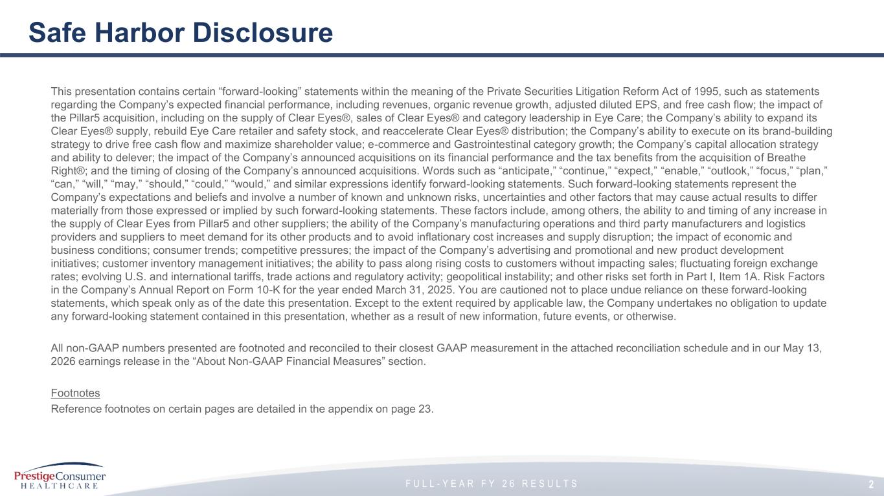
F U L L - Y E A R F Y 2 6 R E S U L T S This presentation contains certain “forward-looking” statements within the meaning of the Private Securities Litigation Reform Act of 1995, such as statements regarding the Company’s expected financial performance, including revenues, organic revenue growth, adjusted diluted EPS, and free cash flow; the impact of the Pillar5 acquisition, including on the supply of Clear Eyes®, sales of Clear Eyes® and category leadership in Eye Care; the Company’s ability to expand its Clear Eyes® supply, rebuild Eye Care retailer and safety stock, and reaccelerate Clear Eyes® distribution; the Company’s ability to execute on its brand-building strategy to drive free cash flow and maximize shareholder value; e-commerce and Gastrointestinal category growth; the Company’s capital allocation strategy and ability to delever; the impact of the Company’s announced acquisitions on its financial performance and the tax benefits from the acquisition of Breathe Right®; and the timing of closing of the Company’s announced acquisitions. Words such as “anticipate,” “continue,” “expect,” “enable,” “outlook,” “focus,” “plan,” “can,” “will,” “may,” “should,” “could,” “would,” and similar expressions identify forward-looking statements. Such forward-looking statements represent the Company’s expectations and beliefs and involve a number of known and unknown risks, uncertainties and other factors that may cause actual results to differ materially from those expressed or implied by such forward-looking statements. These factors include, among others, the ability to and timing of any increase in the supply of Clear Eyes from Pillar5 and other suppliers; the ability of the Company’s manufacturing operations and third party manufacturers and logistics providers and suppliers to meet demand for its other products and to avoid inflationary cost increases and supply disruption; the impact of economic and business conditions; consumer trends; competitive pressures; the impact of the Company’s advertising and promotional and new product development initiatives; customer inventory management initiatives; the ability to pass along rising costs to customers without impacting sales; fluctuating foreign exchange rates; evolving U.S. and international tariffs, trade actions and regulatory activity; geopolitical instability; and other risks set forth in Part I, Item 1A. Risk Factors in the Company’s Annual Report on Form 10-K for the year ended March 31, 2025. You are cautioned not to place undue reliance on these forward-looking statements, which speak only as of the date this presentation. Except to the extent required by applicable law, the Company undertakes no obligation to update any forward-looking statement contained in this presentation, whether as a result of new information, future events, or otherwise. All non-GAAP numbers presented are footnoted and reconciled to their closest GAAP measurement in the attached reconciliation schedule and in our May 13, 2026 earnings release in the “About Non-GAAP Financial Measures” section. Footnotes Reference footnotes on certain pages are detailed in the appendix on page 23. Safe Harbor Disclosure 2

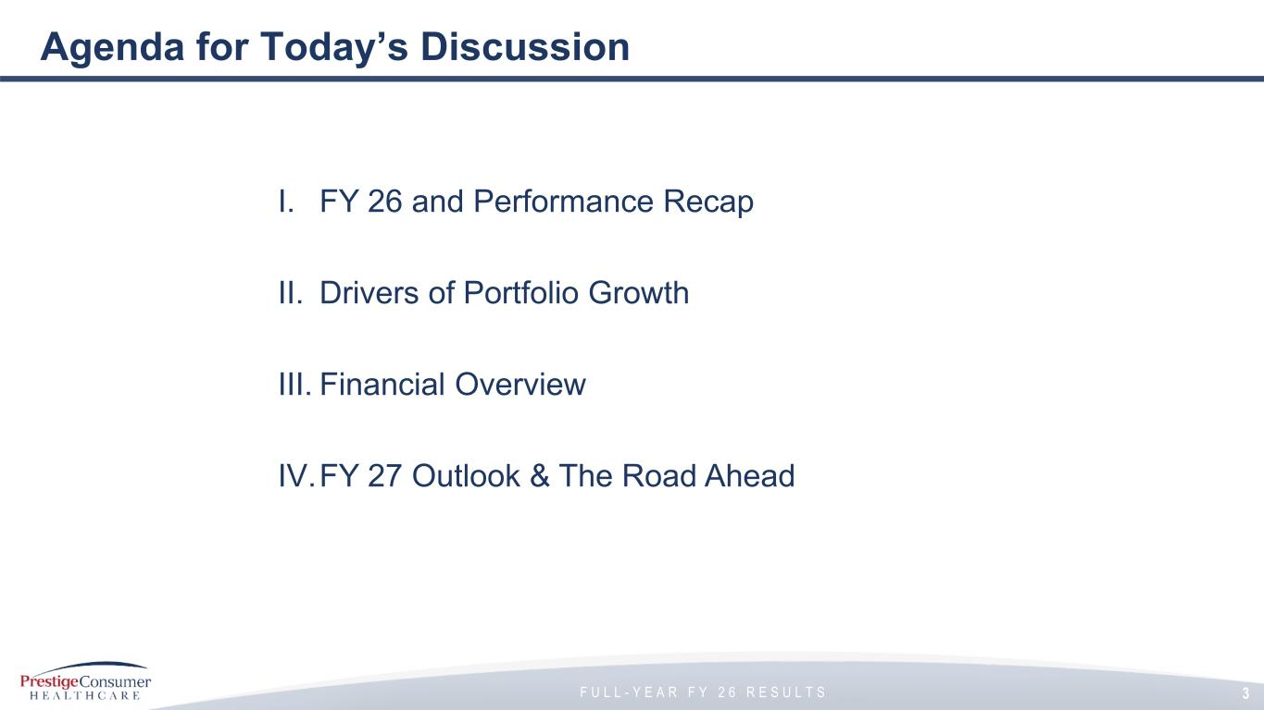
F U L L - Y E A R F Y 2 6 R E S U L T S Agenda for Today’s Discussion 3 I. FY 26 and Performance Recap II. Drivers of Portfolio Growth III. Financial Overview IV.FY 27 Outlook & The Road Ahead

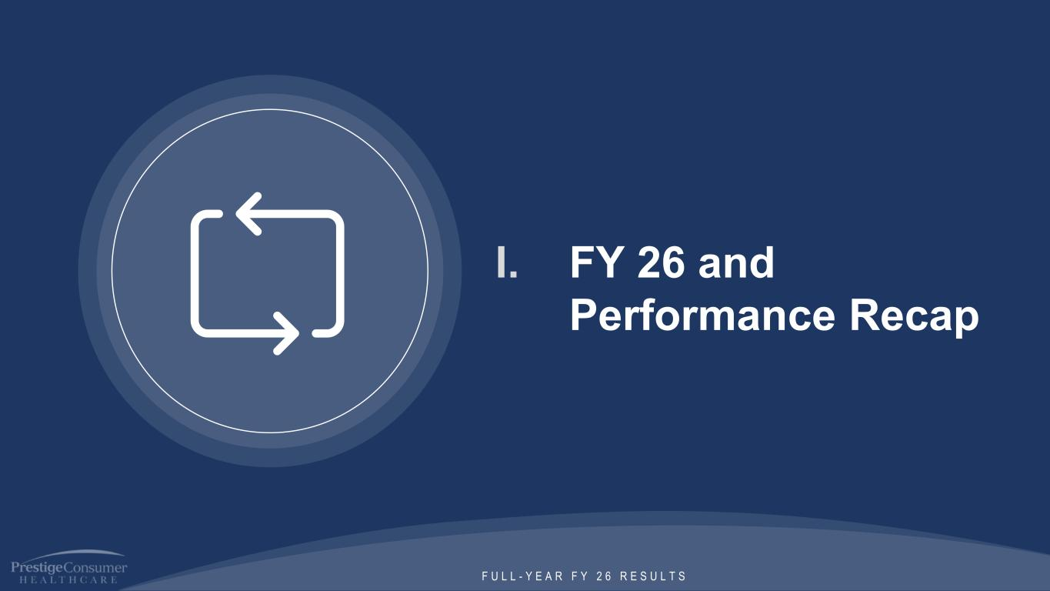
F U L L - Y E A R F Y 2 6 R E S U L T S I. FY 26 and Performance Recap

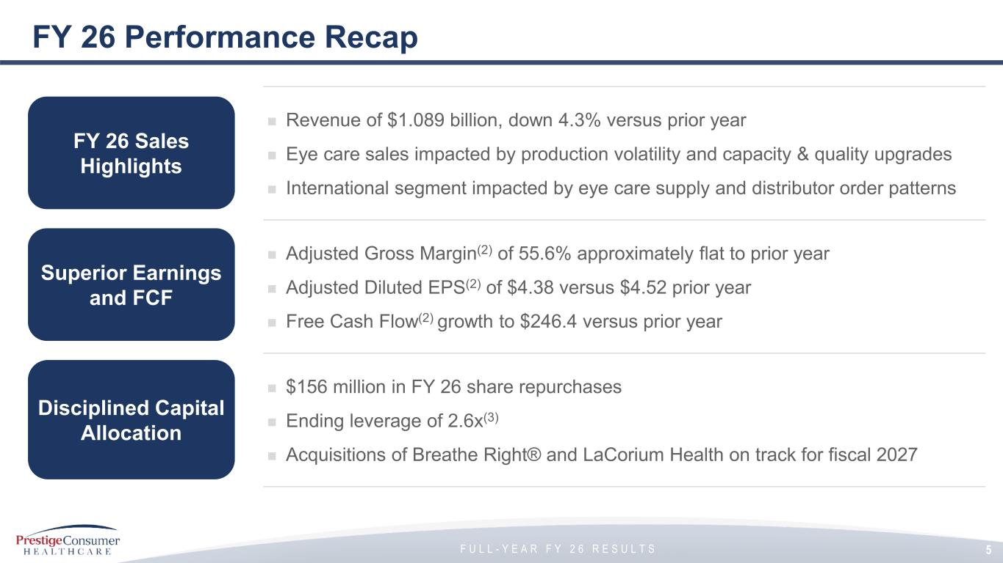
F U L L - Y E A R F Y 2 6 R E S U L T S FY 26 Performance Recap ◼ Revenue of $1.089 billion, down 4.3% versus prior year ◼ Eye care sales impacted by production volatility and capacity & quality upgrades ◼ International segment impacted by eye care supply and distributor order patterns ◼ Adjusted Gross Margin(2) of 55.6% approximately flat to prior year ◼ Adjusted Diluted EPS(2) of $4.38 versus $4.52 prior year ◼ Free Cash Flow(2) growth to $246.4 versus prior year ◼ $156 million in FY 26 share repurchases ◼ Ending leverage of 2.6x(3) ◼ Acquisitions of Breathe Right® and LaCorium Health on track for fiscal 2027 FY 26 Sales Highlights Disciplined Capital Allocation Superior Earnings and FCF 5

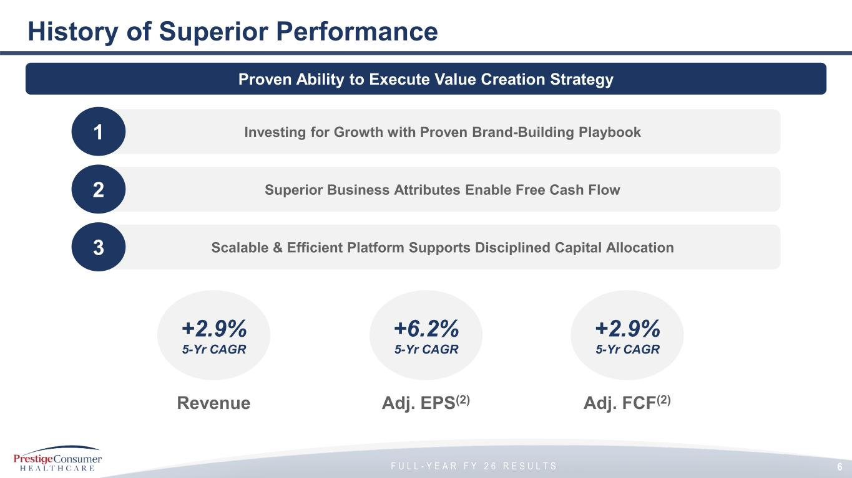
F U L L - Y E A R F Y 2 6 R E S U L T S History of Superior Performance 6 Proven Ability to Execute Value Creation Strategy Investing for Growth with Proven Brand-Building Playbook1 Superior Business Attributes Enable Free Cash Flow2 Scalable & Efficient Platform Supports Disciplined Capital Allocation3 +2.9% 5-Yr CAGR Revenue +6.2% 5-Yr CAGR Adj. EPS(2) +2.9% 5-Yr CAGR Adj. FCF(2)

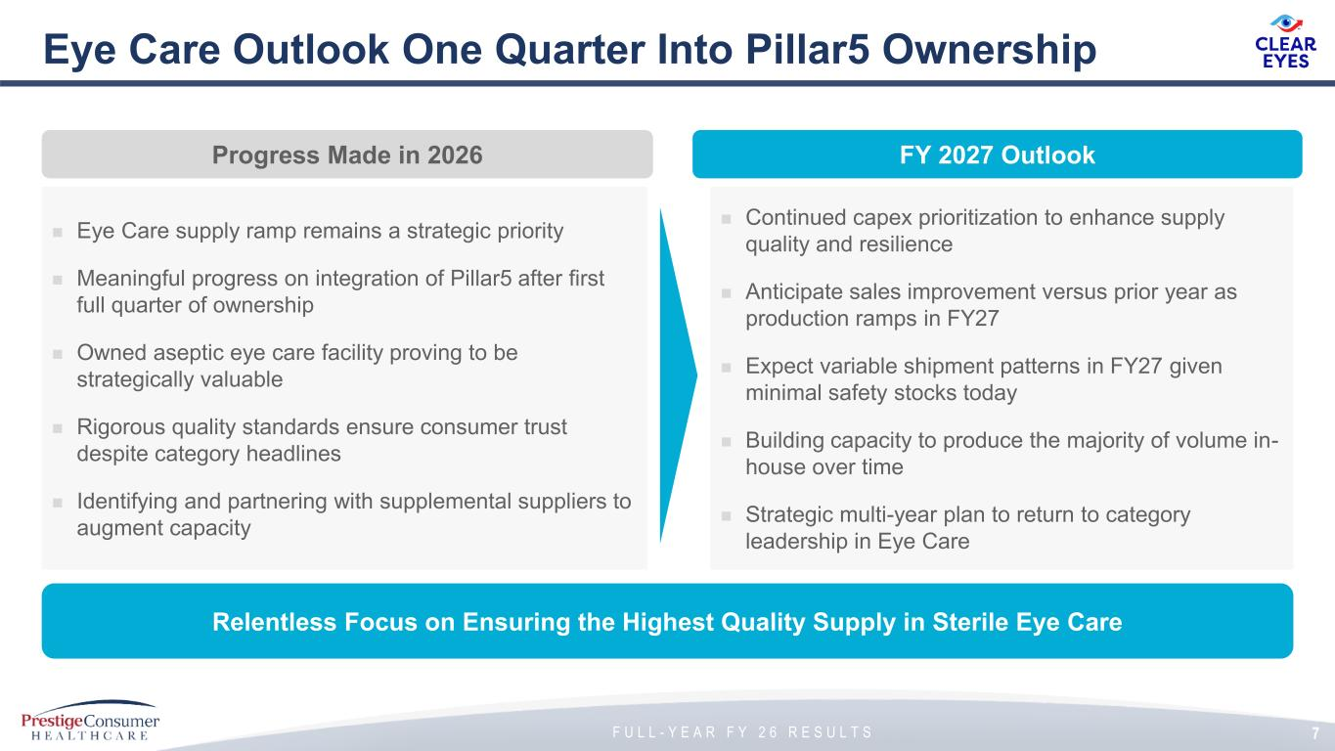
F U L L - Y E A R F Y 2 6 R E S U L T S 7 Eye Care Outlook One Quarter Into Pillar5 Ownership Progress Made in 2026 FY 2027 Outlook Relentless Focus on Ensuring the Highest Quality Supply in Sterile Eye Care ◼ Eye Care supply ramp remains a strategic priority ◼ Meaningful progress on integration of Pillar5 after first full quarter of ownership ◼ Owned aseptic eye care facility proving to be strategically valuable ◼ Rigorous quality standards ensure consumer trust despite category headlines ◼ Identifying and partnering with supplemental suppliers to augment capacity ◼ Continued capex prioritization to enhance supply quality and resilience ◼ Anticipate sales improvement versus prior year as production ramps in FY27 ◼ Expect variable shipment patterns in FY27 given minimal safety stocks today ◼ Building capacity to produce the majority of volume in- house over time ◼ Strategic multi-year plan to return to category leadership in Eye Care


F U L L - Y E A R F Y 2 6 R E S U L T S II. Drivers of Portfolio Growth

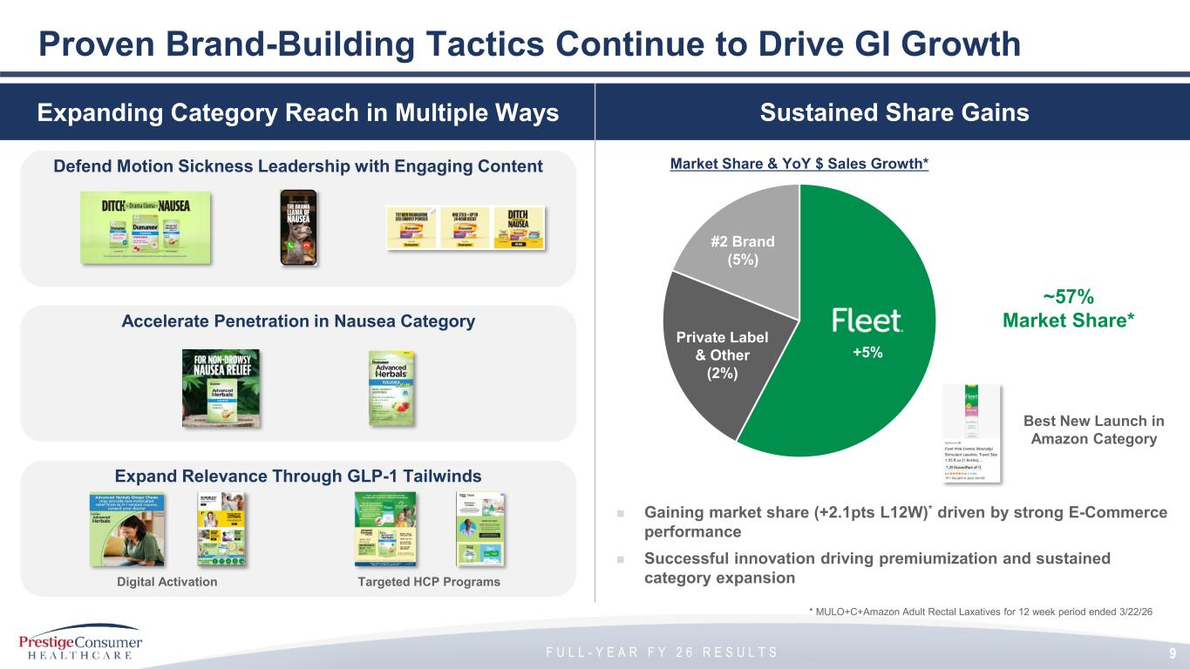
F U L L - Y E A R F Y 2 6 R E S U L T S Proven Brand-Building Tactics Continue to Drive GI Growth Brand-Building Driving Consumption GrowthSustained Share GainsExpanding Category Reach in Multiple Ways ◼ Gaining market share (+2.1pts L12W)* driven by strong E-Commerce performance ◼ Successful innovation driving premiumization and sustained category expansion * MULO+C+Amazon Adult Rectal Laxatives for 12 week period ended 3/22/26 Private Label & Other (2%) #2 Brand (5%) ~57% Market Share* Best New Launch in Amazon Category +5% Market Share & YoY $ Sales Growth* Accelerate Penetration in Nausea Category Defend Motion Sickness Leadership with Engaging Content Expand Relevance Through GLP-1 Tailwinds Digital Activation Targeted HCP Programs 9

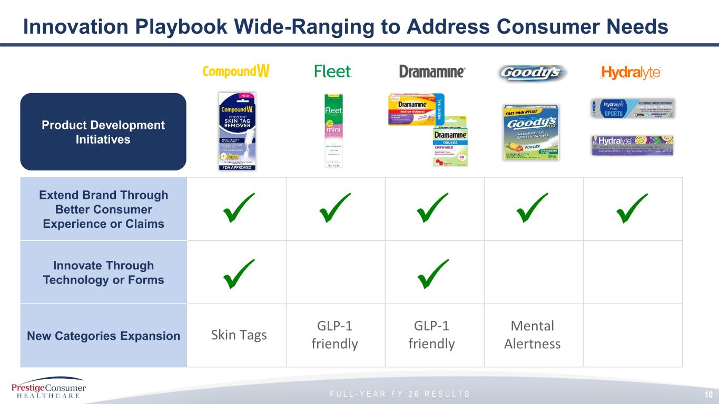
F U L L - Y E A R F Y 2 6 R E S U L T S Innovation Playbook Wide-Ranging to Address Consumer Needs 10 Extend Brand Through Better Consumer Experience or Claims Innovate Through Technology or Forms New Categories Expansion Product Development Initiatives Mental Alertness Skin Tags GLP-1 friendly GLP-1 friendly

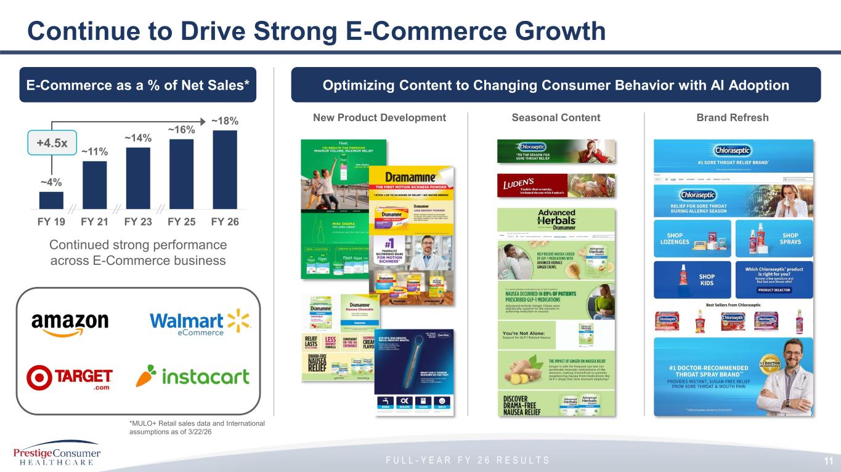
F U L L - Y E A R F Y 2 6 R E S U L T S Continue to Drive Strong E-Commerce Growth 11 Continued strong performance across E-Commerce business *MULO+ Retail sales data and International assumptions as of 3/22/26 Optimizing Content to Changing Consumer Behavior with AI AdoptionE-Commerce as a % of Net Sales* ~4% ~11% ~14% ~16% ~18% FY 19 FY 21 FY 23 FY 25 FY 26 +4.5x New Product Development Seasonal Content Brand Refresh


F U L L - Y E A R F Y 2 6 R E S U L T S III. Financial Overview

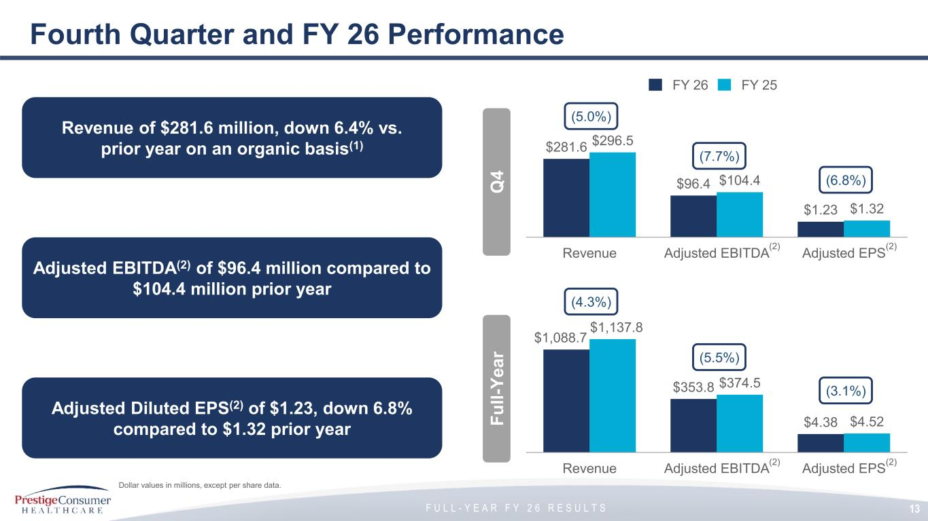
F U L L - Y E A R F Y 2 6 R E S U L T S Fourth Quarter and FY 26 Performance FY 26 FY 25 Dollar values in millions, except per share data. $281.6 $96.4 $1.23 $296.5 $104.4 $1.32 Revenue Adjusted EBITDA Adjusted EPS (5.0%) (7.7%) (6.8%) 13 Q 4 $1,088.7 $353.8 $4.38 $1,137.8 $374.5 $4.52 Revenue Adjusted EBITDA Adjusted EPS (4.3%) (5.5%) (3.1%) (2) Revenue of $281.6 million, down 6.4% vs. prior year on an organic basis(1) Adjusted Diluted EPS(2) of $1.23, down 6.8% compared to $1.32 prior year Adjusted EBITDA(2) of $96.4 million compared to $104.4 million prior year F u ll -Y e a r (2) (2) (2)

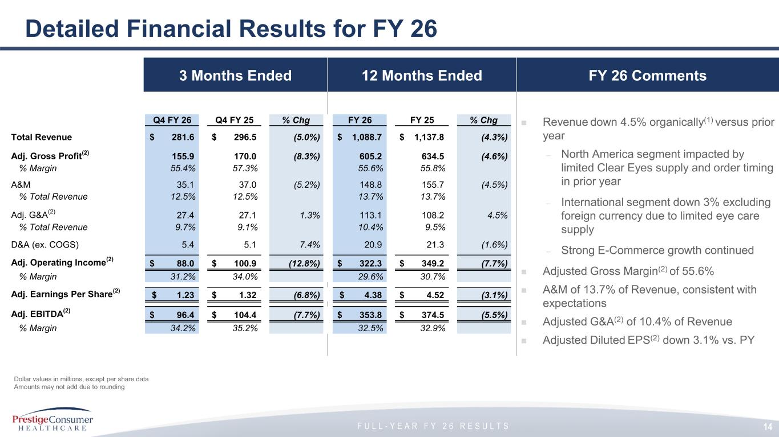
F U L L - Y E A R F Y 2 6 R E S U L T S 3 Months Ended FY 26 Comments Detailed Financial Results for FY 26 ◼ Revenue down 4.5% organically(1) versus prior year – North America segment impacted by limited Clear Eyes supply and order timing in prior year – International segment down 3% excluding foreign currency due to limited eye care supply – Strong E-Commerce growth continued ◼ Adjusted Gross Margin(2) of 55.6% ◼ A&M of 13.7% of Revenue, consistent with expectations ◼ Adjusted G&A(2) of 10.4% of Revenue ◼ Adjusted Diluted EPS(2) down 3.1% vs. PY Dollar values in millions, except per share data Amounts may not add due to rounding 14 12 Months Ended Q4 FY 26 Q4 FY 25 % Chg FY 26 FY 25 % Chg Total Revenue 281.6$ 296.5$ (5.0%) 1,088.7$ 1,137.8$ (4.3%) Adj. Gross Profit (2) 155.9 170.0 (8.3%) 605.2 634.5 (4.6%) % Margin 55.4% 57.3% 55.6% 55.8% A&M 35.1 37.0 (5.2%) 148.8 155.7 (4.5%) % Total Revenue 12.5% 12.5% 13.7% 13.7% Adj. G&A (2) 27.4 27.1 1.3% 113.1 108.2 4.5% % Total Revenue 9.7% 9.1% 10.4% 9.5% D&A (ex. COGS) 5.4 5.1 7.4% 20.9 21.3 (1.6%) Adj. Operating Income (2) 88.0$ 100.9$ (12.8%) 322.3$ 349.2$ (7.7%) % Margin 31.2% 34.0% 29.6% 30.7% Adj. Earnings Per Share (2) 1.23$ 1.32$ (6.8%) 4.38$ 4.52$ (3.1%) Adj. EBITDA (2) 96.4$ 104.4$ (7.7%) 353.8$ 374.5$ (5.5%) % Margin 34.2% 35.2% 32.5% 32.9%

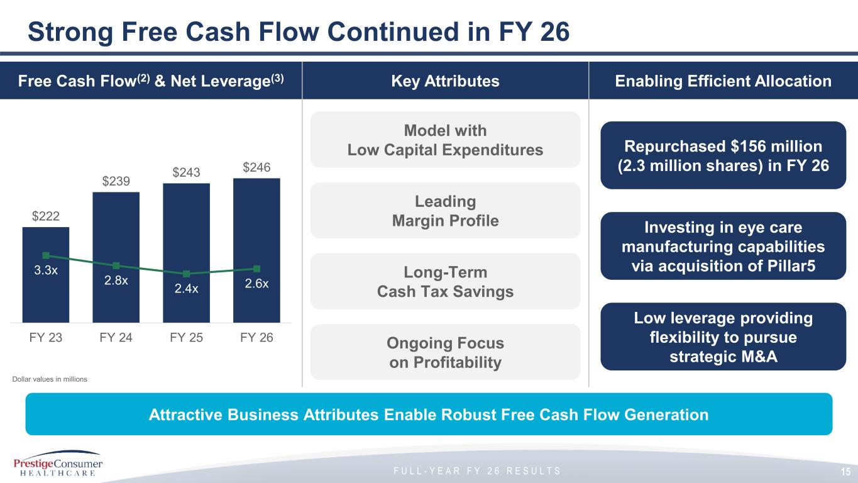
F U L L - Y E A R F Y 2 6 R E S U L T S Strong Free Cash Flow Continued in FY 26 Attractive Business Attributes Enable Robust Free Cash Flow Generation 15 Free Cash Flow(2) & Net Leverage(3) Enabling Efficient Allocation Dollar values in millions $222 $239 $243 $246 3.3x 2.8x 2.4x 2.6x FY 23 FY 24 FY 25 FY 26 Model with Low Capital Expenditures Leading Margin Profile Long-Term Cash Tax Savings Ongoing Focus on Profitability Key Attributes Repurchased $156 million (2.3 million shares) in FY 26 Investing in eye care manufacturing capabilities via acquisition of Pillar5 Low leverage providing flexibility to pursue strategic M&A

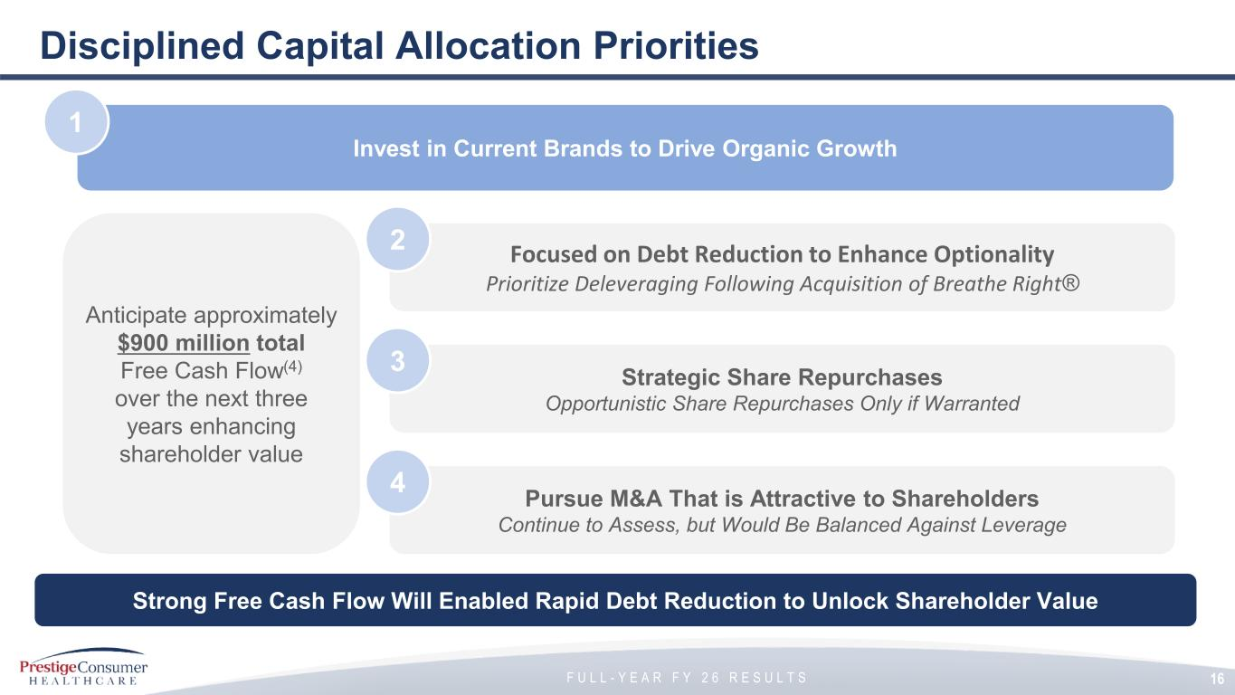
F U L L - Y E A R F Y 2 6 R E S U L T S Disciplined Capital Allocation Priorities 16 Invest in Current Brands to Drive Organic Growth 1 Focused on Debt Reduction to Enhance Optionality Prioritize Deleveraging Following Acquisition of Breathe Right® 2 Strategic Share Repurchases Opportunistic Share Repurchases Only if Warranted 3 Pursue M&A That is Attractive to Shareholders Continue to Assess, but Would Be Balanced Against Leverage 4 Strong Free Cash Flow Will Enabled Rapid Debt Reduction to Unlock Shareholder Value Anticipate approximately $900 million total Free Cash Flow(4) over the next three years enhancing shareholder value 16


F U L L - Y E A R F Y 2 6 R E S U L T S IV. FY 27 Outlook & The Road Ahead

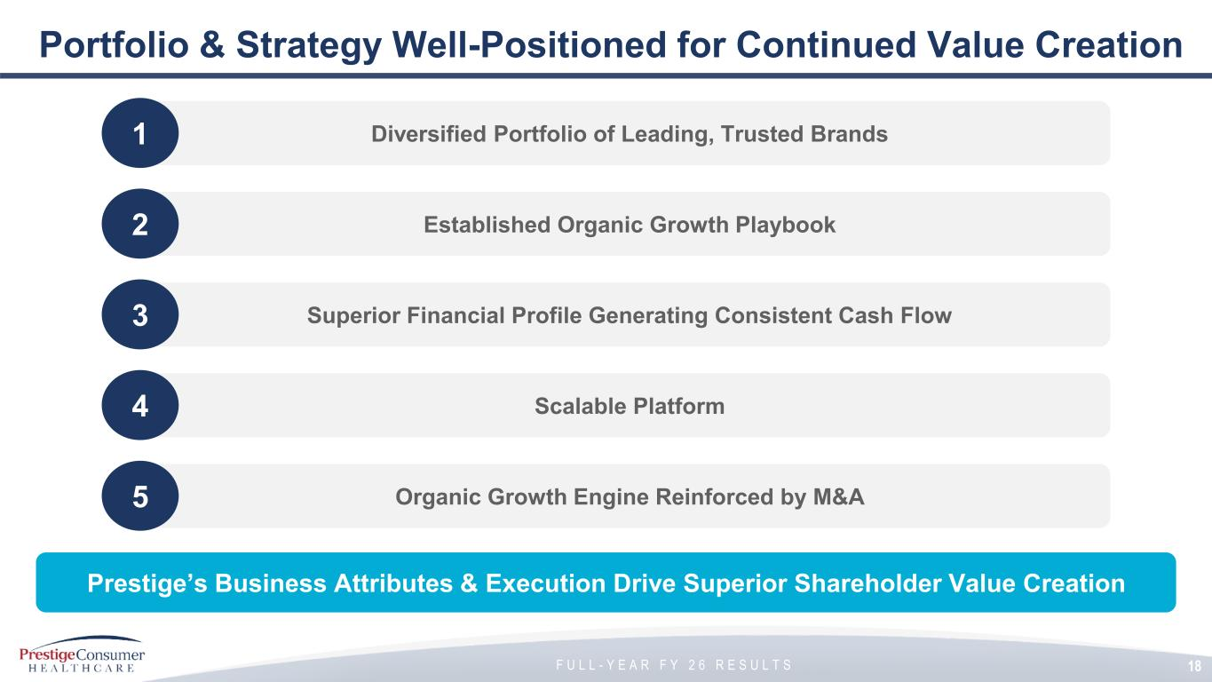
F U L L - Y E A R F Y 2 6 R E S U L T S Portfolio & Strategy Well-Positioned for Continued Value Creation 18 Diversified Portfolio of Leading, Trusted Brands1 Established Organic Growth Playbook2 Superior Financial Profile Generating Consistent Cash Flow3 Scalable Platform4 Organic Growth Engine Reinforced by M&A5 Prestige’s Business Attributes & Execution Drive Superior Shareholder Value Creation

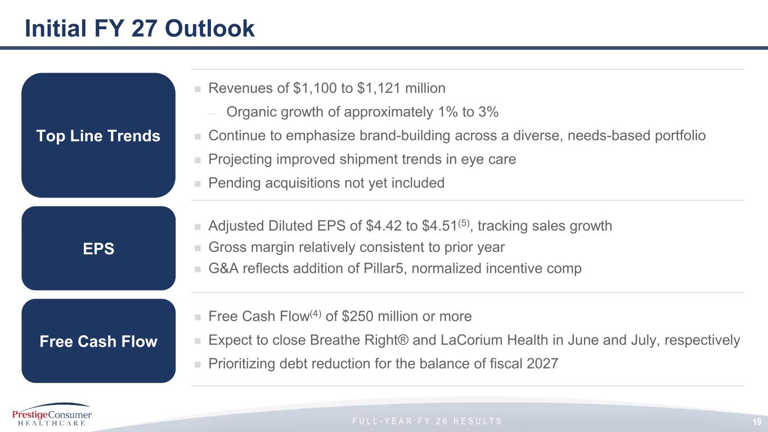
F U L L - Y E A R F Y 2 6 R E S U L T S Initial FY 27 Outlook ◼ Revenues of $1,100 to $1,121 million — Organic growth of approximately 1% to 3% ◼ Continue to emphasize brand-building across a diverse, needs-based portfolio ◼ Projecting improved shipment trends in eye care ◼ Pending acquisitions not yet included ◼ Adjusted Diluted EPS of $4.42 to $4.51(5), tracking sales growth ◼ Gross margin relatively consistent to prior year ◼ G&A reflects addition of Pillar5, normalized incentive comp ◼ Free Cash Flow(4) of $250 million or more ◼ Expect to close Breathe Right® and LaCorium Health in June and July, respectively ◼ Prioritizing debt reduction for the balance of fiscal 2027 Top Line Trends Free Cash Flow EPS 19

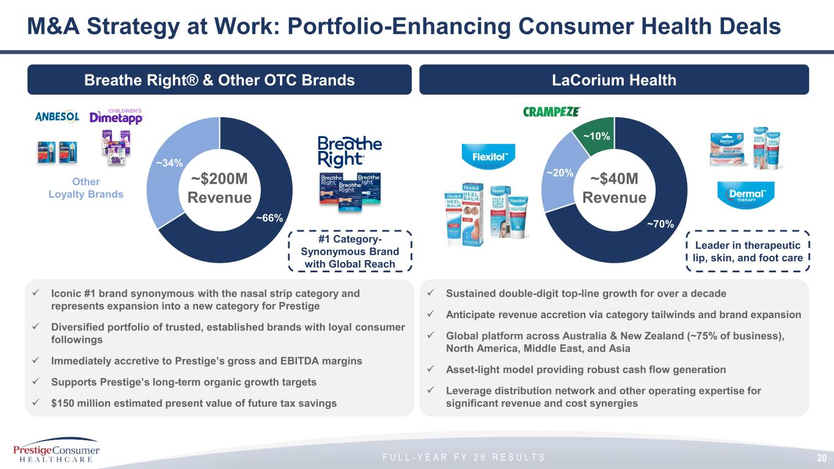
F U L L - Y E A R F Y 2 6 R E S U L T S M&A Strategy at Work: Portfolio-Enhancing Consumer Health Deals ✓ Iconic #1 brand synonymous with the nasal strip category and represents expansion into a new category for Prestige ✓ Diversified portfolio of trusted, established brands with loyal consumer followings ✓ Immediately accretive to Prestige’s gross and EBITDA margins ✓ Supports Prestige’s long-term organic growth targets ✓ $150 million estimated present value of future tax savings ~66% ~34% ~$200M Revenue Other Loyalty Brands #1 Category- Synonymous Brand with Global Reach ✓ Sustained double-digit top-line growth for over a decade ✓ Anticipate revenue accretion via category tailwinds and brand expansion ✓ Global platform across Australia & New Zealand (~75% of business), North America, Middle East, and Asia ✓ Asset-light model providing robust cash flow generation ✓ Leverage distribution network and other operating expertise for significant revenue and cost synergies ~70% ~20% ~10% ~$40M Revenue Leader in therapeutic lip, skin, and foot care 20 Breathe Right® & Other OTC Brands LaCorium Health

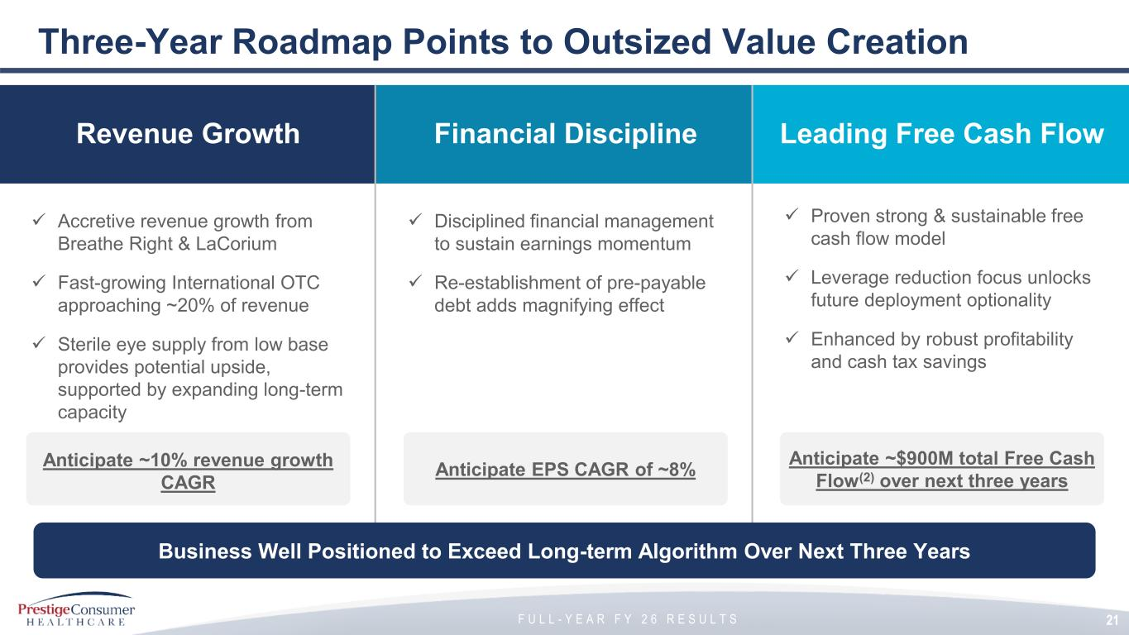
F U L L - Y E A R F Y 2 6 R E S U L T S Three-Year Roadmap Points to Outsized Value Creation Revenue Growth Financial Discipline Leading Free Cash Flow ✓ Proven strong & sustainable free cash flow model ✓ Leverage reduction focus unlocks future deployment optionality ✓ Enhanced by robust profitability and cash tax savings 21 Anticipate ~10% revenue growth CAGR Anticipate EPS CAGR of ~8% ✓ Accretive revenue growth from Breathe Right & LaCorium ✓ Fast-growing International OTC approaching ~20% of revenue ✓ Sterile eye supply from low base provides potential upside, supported by expanding long-term capacity ✓ Disciplined financial management to sustain earnings momentum ✓ Re-establishment of pre-payable debt adds magnifying effect Anticipate ~$900M total Free Cash Flow(2) over next three years Business Well Positioned to Exceed Long-term Algorithm Over Next Three Years

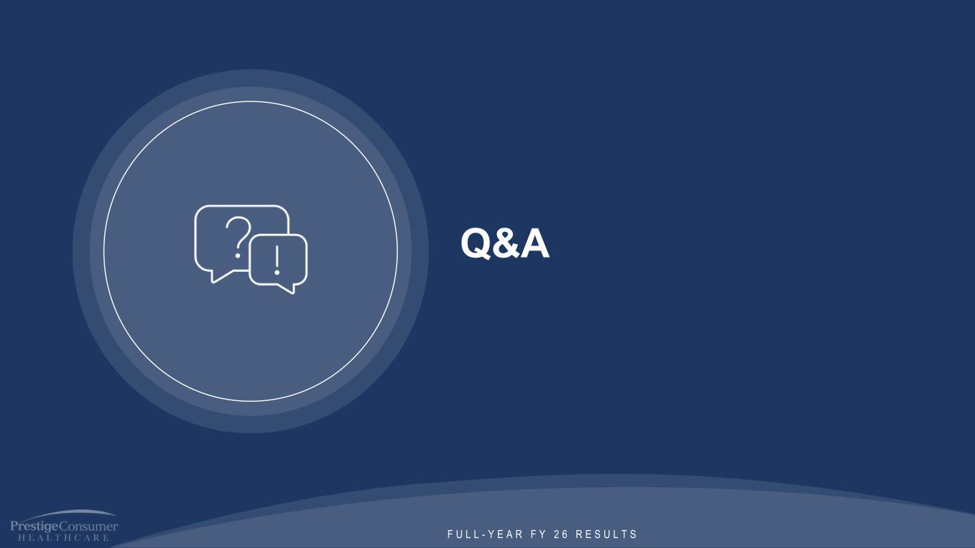
F U L L - Y E A R F Y 2 6 R E S U L T S Q&A

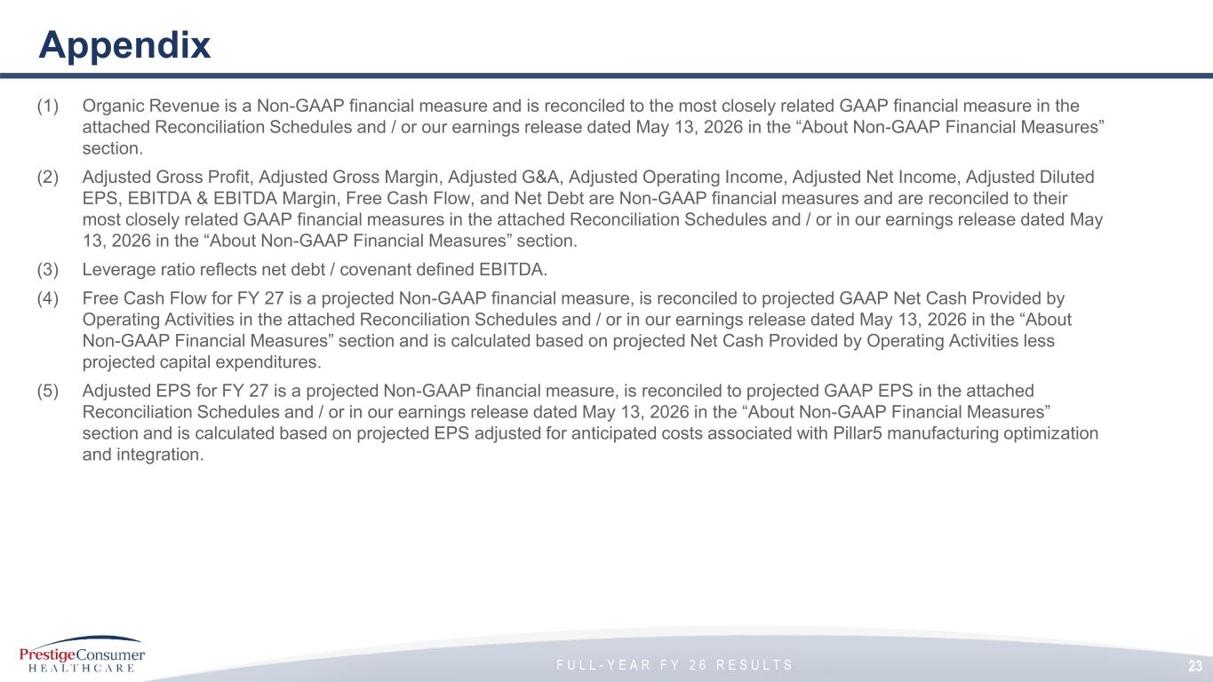
F U L L - Y E A R F Y 2 6 R E S U L T S Appendix (1) Organic Revenue is a Non-GAAP financial measure and is reconciled to the most closely related GAAP financial measure in the attached Reconciliation Schedules and / or our earnings release dated May 13, 2026 in the “About Non-GAAP Financial Measures” section. (2) Adjusted Gross Profit, Adjusted Gross Margin, Adjusted G&A, Adjusted Operating Income, Adjusted Net Income, Adjusted Diluted EPS, EBITDA & EBITDA Margin, Free Cash Flow, and Net Debt are Non-GAAP financial measures and are reconciled to their most closely related GAAP financial measures in the attached Reconciliation Schedules and / or in our earnings release dated May 13, 2026 in the “About Non-GAAP Financial Measures” section. (3) Leverage ratio reflects net debt / covenant defined EBITDA. (4) Free Cash Flow for FY 27 is a projected Non-GAAP financial measure, is reconciled to projected GAAP Net Cash Provided by Operating Activities in the attached Reconciliation Schedules and / or in our earnings release dated May 13, 2026 in the “About Non-GAAP Financial Measures” section and is calculated based on projected Net Cash Provided by Operating Activities less projected capital expenditures. (5) Adjusted EPS for FY 27 is a projected Non-GAAP financial measure, is reconciled to projected GAAP EPS in the attached Reconciliation Schedules and / or in our earnings release dated May 13, 2026 in the “About Non-GAAP Financial Measures” section and is calculated based on projected EPS adjusted for anticipated costs associated with Pillar5 manufacturing optimization and integration. 23

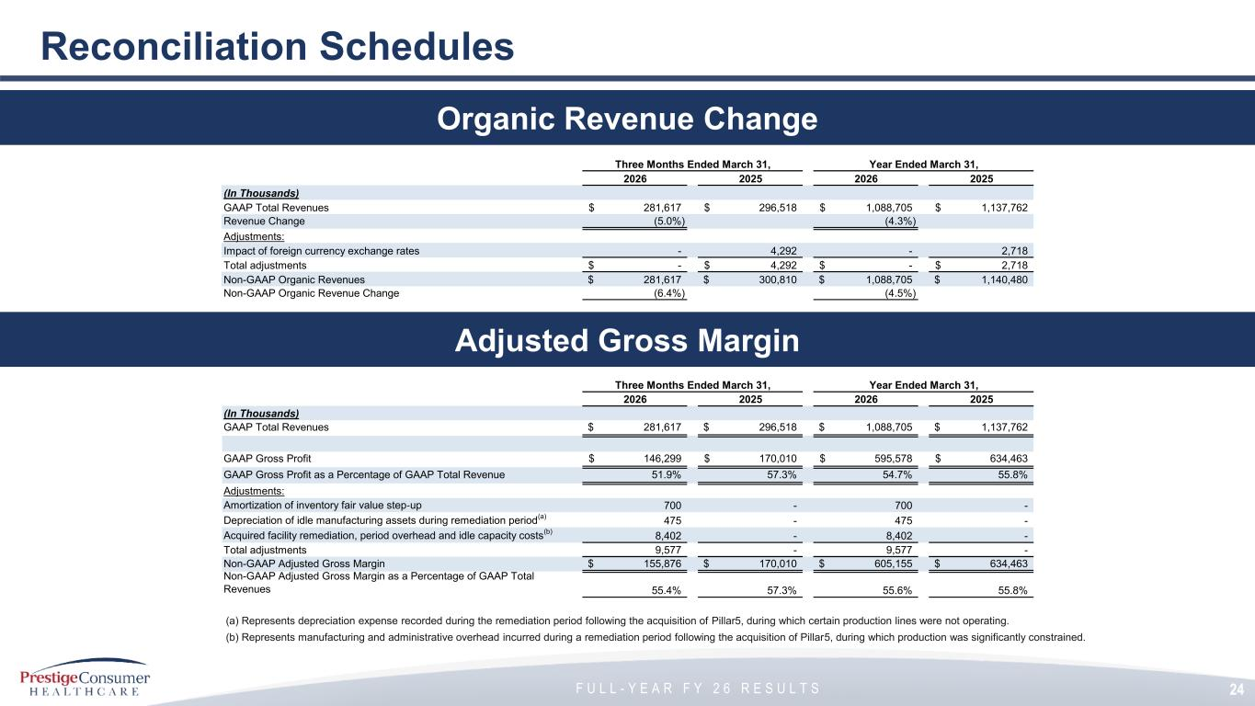
F U L L - Y E A R F Y 2 6 R E S U L T S 24 Reconciliation Schedules Adjusted Gross Margin Organic Revenue Change Three Months Ended March 31, Year Ended March 31, 2026 2025 2026 2025 (In Thousands) GAAP Total Revenues 281,617$ 296,518$ 1,088,705$ 1,137,762$ Revenue Change (5.0%) (4.3%) Adjustments: Impact of foreign currency exchange rates - 4,292 - 2,718 Total adjustments -$ 4,292$ -$ 2,718$ Non-GAAP Organic Revenues 281,617$ 300,810$ 1,088,705$ 1,140,480$ Non-GAAP Organic Revenue Change (6.4%) (4.5%) (a) Represents depreciation expense recorded during the remediation period following the acquisition of Pillar5, during which certain production lines were not operating. (b) Represents manufacturing and administrative overhead incurred during a remediation period following the acquisition of Pillar5, during which production was significantly constrained. Three Months Ended March 31, Year Ended March 31, 2026 2025 2026 2025 (In Thousands) GAAP Total Revenues 281,617$ 296,518$ 1,088,705$ 1,137,762$ GAAP Gross Profit 146,299$ 170,010$ 595,578$ 634,463$ GAAP Gross Profit as a Percentage of GAAP Total Revenue 51.9% 57.3% 54.7% 55.8% Adjustments: Amortization of inventory fair value step-up 700 - 700 - Depreciation of idle manufacturing assets during remediation period (a) 475 - 475 - Acquired facility remediation, period overhead and idle capacity costs (b) 8,402 - 8,402 - Total adjustments 9,577 - 9,577 - Non-GAAP Adjusted Gross Margin 155,876$ 170,010$ 605,155$ 634,463$ Non-GAAP Adjusted Gross Margin as a Percentage of GAAP Total Revenues 55.4% 57.3% 55.6% 55.8%

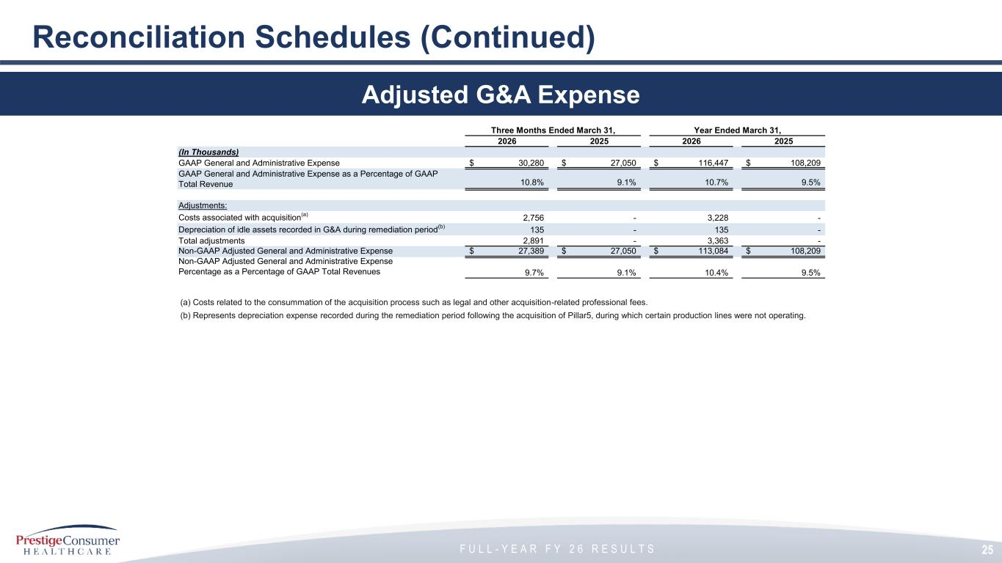
F U L L - Y E A R F Y 2 6 R E S U L T S 25 Reconciliation Schedules (Continued) Adjusted G&A Expense (a) Costs related to the consummation of the acquisition process such as legal and other acquisition-related professional fees. (b) Represents depreciation expense recorded during the remediation period following the acquisition of Pillar5, during which certain production lines were not operating. Three Months Ended March 31, Year Ended March 31, 2026 2025 2026 2025 (In Thousands) GAAP General and Administrative Expense 30,280$ 27,050$ 116,447$ 108,209$ GAAP General and Administrative Expense as a Percentage of GAAP Total Revenue 10.8% 9.1% 10.7% 9.5% Adjustments: Costs associated with acquisition (a) 2,756 - 3,228 - Depreciation of idle assets recorded in G&A during remediation period (b) 135 - 135 - Total adjustments 2,891 - 3,363 - Non-GAAP Adjusted General and Administrative Expense 27,389$ 27,050$ 113,084$ 108,209$ Non-GAAP Adjusted General and Administrative Expense Percentage as a Percentage of GAAP Total Revenues 9.7% 9.1% 10.4% 9.5%

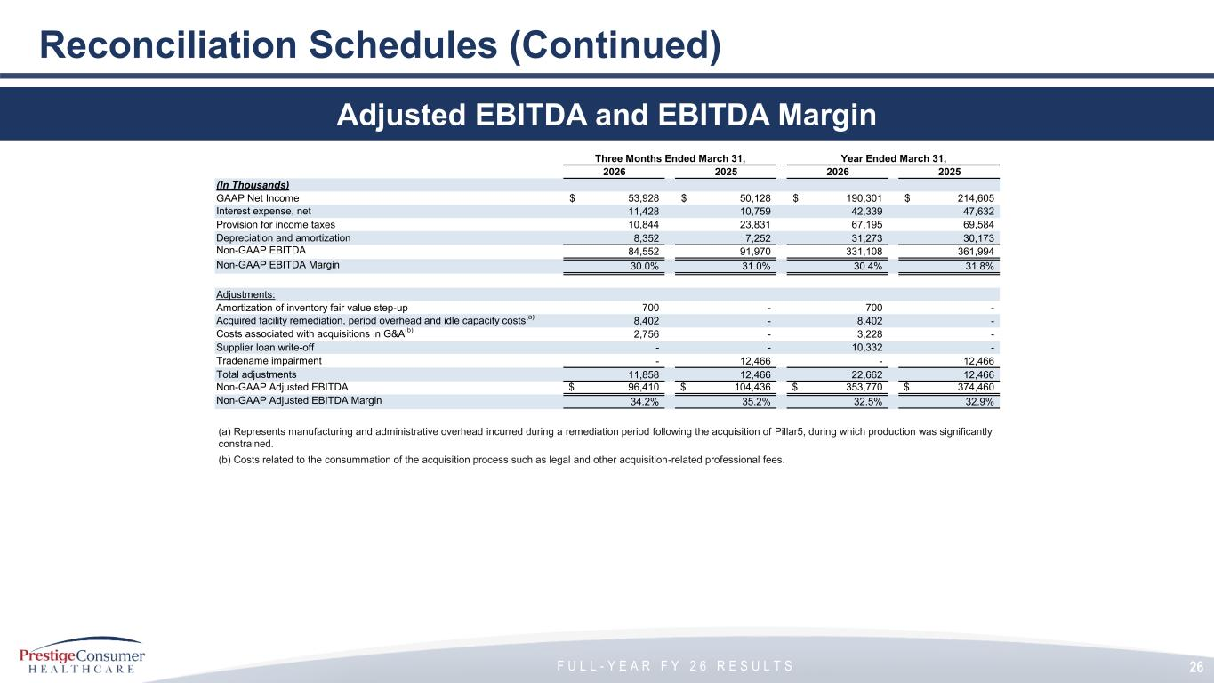
F U L L - Y E A R F Y 2 6 R E S U L T S 26 Reconciliation Schedules (Continued) Adjusted EBITDA and EBITDA Margin (a) Represents manufacturing and administrative overhead incurred during a remediation period following the acquisition of Pillar5, during which production was significantly constrained. (b) Costs related to the consummation of the acquisition process such as legal and other acquisition-related professional fees. Three Months Ended March 31, Year Ended March 31, 2026 2025 2026 2025 (In Thousands) GAAP Net Income 53,928$ 50,128$ 190,301$ 214,605$ Interest expense, net 11,428 10,759 42,339 47,632 Provision for income taxes 10,844 23,831 67,195 69,584 Depreciation and amortization 8,352 7,252 31,273 30,173 Non-GAAP EBITDA 84,552 91,970 331,108 361,994 Non-GAAP EBITDA Margin 30.0% 31.0% 30.4% 31.8% Adjustments: Amortization of inventory fair value step-up 700 - 700 - Acquired facility remediation, period overhead and idle capacity costs (a) 8,402 - 8,402 - Costs associated with acquisitions in G&A (b) 2,756 - 3,228 - Supplier loan write-off - - 10,332 - Tradename impairment - 12,466 - 12,466 Total adjustments 11,858 12,466 22,662 12,466 Non-GAAP Adjusted EBITDA 96,410$ 104,436$ 353,770$ 374,460$ Non-GAAP Adjusted EBITDA Margin 34.2% 35.2% 32.5% 32.9%

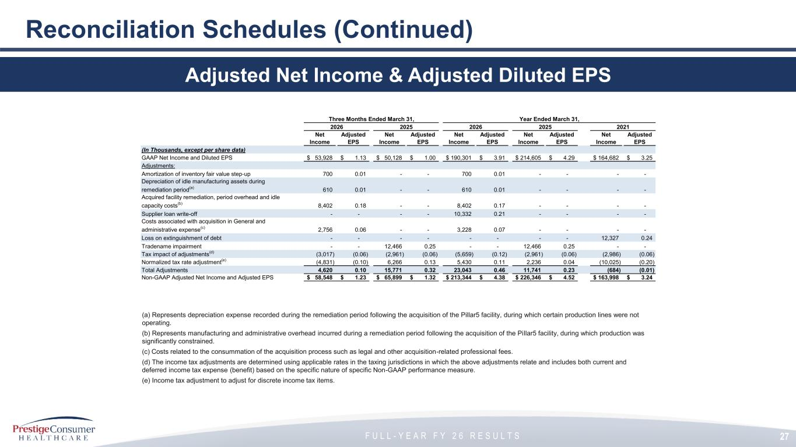
F U L L - Y E A R F Y 2 6 R E S U L T S 27 Reconciliation Schedules (Continued) Adjusted Net Income & Adjusted Diluted EPS Three Months Ended March 31, Year Ended March 31, 2026 2025 2026 2025 2021 Net Income Adjusted EPS Net Income Adjusted EPS Net Income Adjusted EPS Net Income Adjusted EPS Net Income Adjusted EPS (In Thousands, except per share data) GAAP Net Income and Diluted EPS 53,928$ 1.13$ 50,128$ 1.00$ 190,301$ 3.91$ 214,605$ 4.29$ 164,682$ 3.25$ Adjustments: Amortization of inventory fair value step-up 700 0.01 - - 700 0.01 - - - - Depreciation of idle manufacturing assets during remediation period (a) 610 0.01 - - 610 0.01 - - - - Acquired facility remediation, period overhead and idle capacity costs (b) 8,402 0.18 - - 8,402 0.17 - - - - Supplier loan write-off - - - - 10,332 0.21 - - - - Costs associated with acquisition in General and administrative expense (c) 2,756 0.06 - - 3,228 0.07 - - - - Loss on extinguishment of debt - - - - - - - - 12,327 0.24 Tradename impairment - - 12,466 0.25 - - 12,466 0.25 - - Tax impact of adjustments (d) (3,017) (0.06) (2,961) (0.06) (5,659) (0.12) (2,961) (0.06) (2,986) (0.06) Normalized tax rate adjustment (e) (4,831) (0.10) 6,266 0.13 5,430 0.11 2,236 0.04 (10,025) (0.20) Total Adjustments 4,620 0.10 15,771 0.32 23,043 0.46 11,741 0.23 (684) (0.01) Non-GAAP Adjusted Net Income and Adjusted EPS 58,548$ 1.23$ 65,899$ 1.32$ 213,344$ 4.38$ 226,346$ 4.52$ 163,998$ 3.24$ (a) Represents depreciation expense recorded during the remediation period following the acquisition of the Pillar5 facility, during which certain production lines were not operating. (b) Represents manufacturing and administrative overhead incurred during a remediation period following the acquisition of the Pillar5 facility, during which production was significantly constrained. (c) Costs related to the consummation of the acquisition process such as legal and other acquisition-related professional fees. (d) The income tax adjustments are determined using applicable rates in the taxing jurisdictions in which the above adjustments relate and includes both current and deferred income tax expense (benefit) based on the specific nature of specific Non-GAAP performance measure. (e) Income tax adjustment to adjust for discrete income tax items.

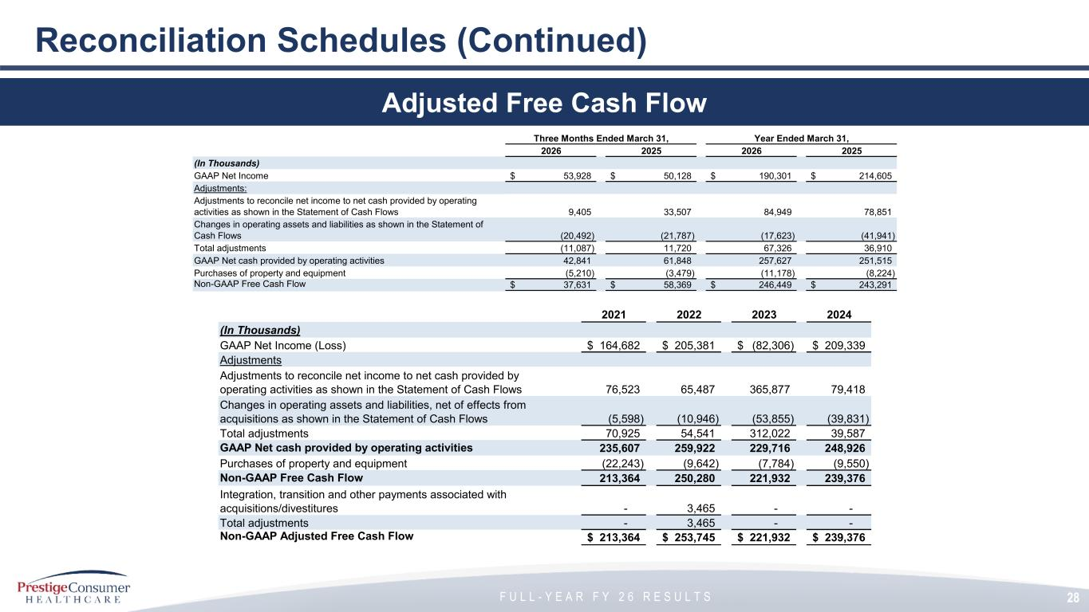
F U L L - Y E A R F Y 2 6 R E S U L T S 28 Reconciliation Schedules (Continued) Adjusted Free Cash Flow Three Months Ended March 31, Year Ended March 31, 2026 2025 2026 2025 (In Thousands) GAAP Net Income 53,928$ 50,128$ 190,301$ 214,605$ Adjustments: Adjustments to reconcile net income to net cash provided by operating activities as shown in the Statement of Cash Flows 9,405 33,507 84,949 78,851 Changes in operating assets and liabilities as shown in the Statement of Cash Flows (20,492) (21,787) (17,623) (41,941) Total adjustments (11,087) 11,720 67,326 36,910 GAAP Net cash provided by operating activities 42,841 61,848 257,627 251,515 Purchases of property and equipment (5,210) (3,479) (11,178) (8,224) Non-GAAP Free Cash Flow 37,631$ 58,369$ 246,449$ 243,291$ 2021 2022 2023 2024 (In Thousands) GAAP Net Income (Loss) 164,682$ 205,381$ (82,306)$ 209,339$ Adjustments Adjustments to reconcile net income to net cash provided by operating activities as shown in the Statement of Cash Flows 76,523 65,487 365,877 79,418 Changes in operating assets and liabilities, net of effects from acquisitions as shown in the Statement of Cash Flows (5,598) (10,946) (53,855) (39,831) Total adjustments 70,925 54,541 312,022 39,587 GAAP Net cash provided by operating activities 235,607 259,922 229,716 248,926 Purchases of property and equipment (22,243) (9,642) (7,784) (9,550) Non-GAAP Free Cash Flow 213,364 250,280 221,932 239,376 Integration, transition and other payments associated with acquisitions/divestitures - 3,465 - - Total adjustments - 3,465 - - Non-GAAP Adjusted Free Cash Flow 213,364$ 253,745$ 221,932$ 239,376$

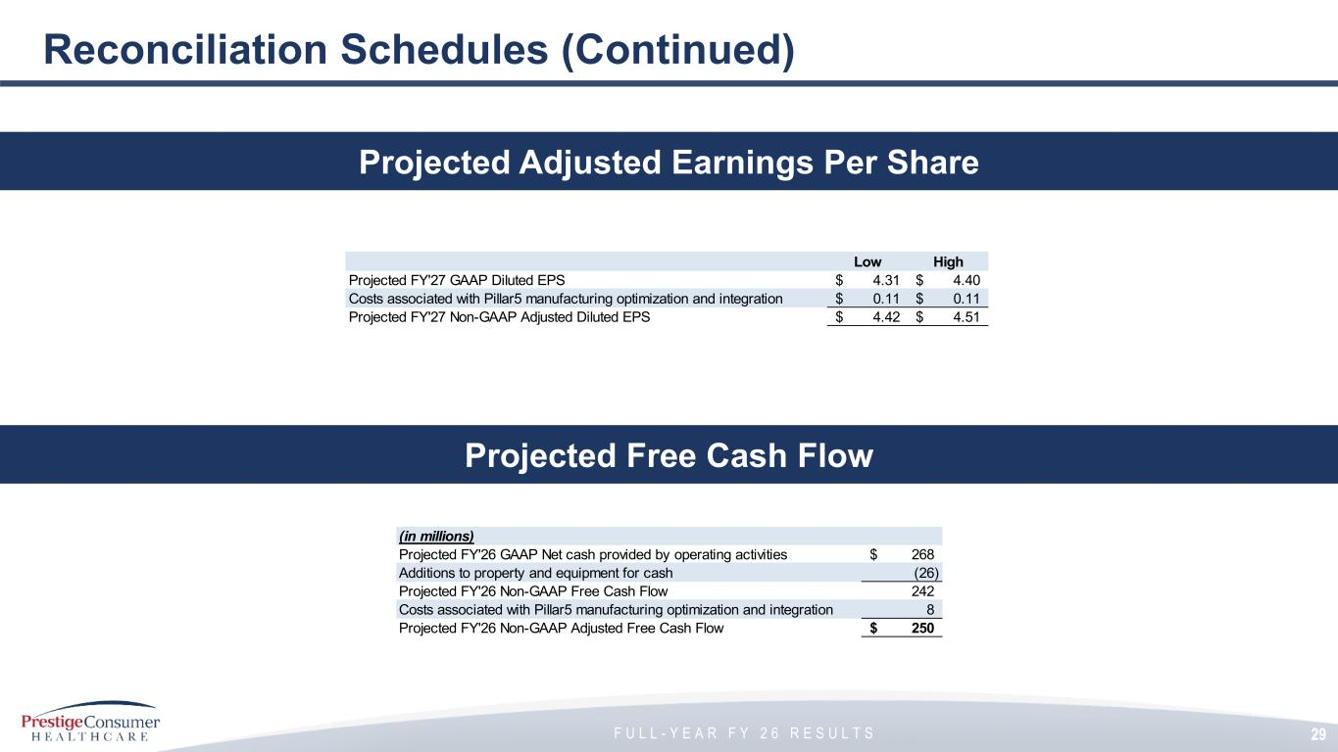
F U L L - Y E A R F Y 2 6 R E S U L T S 29 Reconciliation Schedules (Continued) Projected Free Cash Flow Projected Adjusted Earnings Per Share Low High Projected FY'27 GAAP Diluted EPS 4.31$ 4.40$ Costs associated with Pillar5 manufacturing optimization and integration 0.11$ 0.11$ Projected FY'27 Non-GAAP Adjusted Diluted EPS 4.42$ 4.51$ (in millions) Projected FY'26 GAAP Net cash provided by operating activities 268$ Additions to property and equipment for cash (26) Projected FY'26 Non-GAAP Free Cash Flow 242 Costs associated with Pillar5 manufacturing optimization and integration 8 Projected FY'26 Non-GAAP Adjusted Free Cash Flow 250$

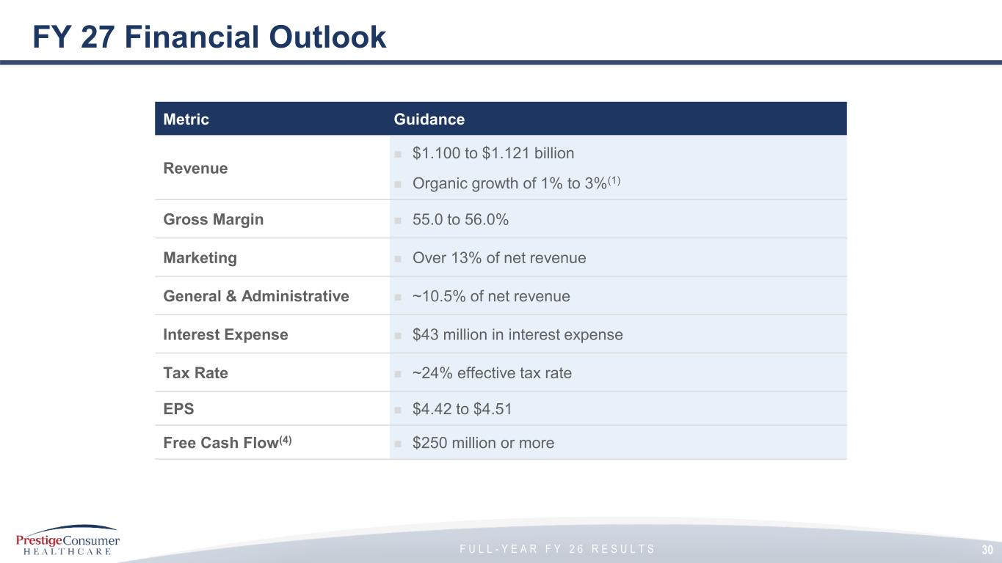
F U L L - Y E A R F Y 2 6 R E S U L T S FY 27 Financial Outlook Metric Guidance Revenue ◼ $1.100 to $1.121 billion ◼ Organic growth of 1% to 3%(1) Gross Margin ◼ 55.0 to 56.0% Marketing ◼ Over 13% of net revenue General & Administrative ◼ ~10.5% of net revenue Interest Expense ◼ $43 million in interest expense Tax Rate ◼ ~24% effective tax rate EPS ◼ $4.42 to $4.51 Free Cash Flow(4) ◼ $250 million or more 30

